*A project report on*

# AGROBOT IN FIELD OF MACHINE LEARNING

*Submitted in partial fulfillment for the award of the degree of*

## Bachelor of Technology

## in

## Computer Science and Engineering

*By*

**PUTUL SIDDHARTH (17BCE1100)**

*Under The Guidance Of*

Dr. B V A N S S Prabhakar Rao



**SCHOOL OF COMPUTER SCIENCE AND ENGINEERING**

June, 2021



**DECLARATION**

This is to certify that the Project work titled “Agrobot in field of machine learning*”* is being submitted by Putul Siddharth (17BCE1100) is in partial fulfillment of the requirements the award of Bachelor of Technology in Computer Science and Engineering, is a record of bonafide work done under my guidance. The contents of this Project work, in full or in parts, have neither been taken from any other source nor have been submitted to any other Institute or University for award of any degree or diploma and the same is certified.

I further declare that the work reported in this thesis has not been submitted and will not be submitted, either in part or in full, for the award of any other degree or diploma in this institute or any other institute or university.

Place: Chennai **Putul Siddharth**

Date: 10/06/2021 Signature of the Candidate



**School of Computer Science and Engineering**

CERTIFICATE

This is to certify that the report entitled **“Agrobot in field of machine learning”** is prepared and submitted by **Putul Siddharth (17BCE1100)** to VIT Chennai, in partial fulfillment of the requirement for the award of the degree of **B.Tech. CSE** programme is a bonafide record carried out under my guidance. The project fulfills the requirements as per the regulations of this University and in my opinion meets the necessary standards for submission. The contents of this report have not been submitted and will not be submitted either in part or in full, for the award of any other degree or diploma and the same is certified.

Signature of the Guide:

Name: Dr. Rao

Date: 10/06/2021

Signature of the Internal Examiner Signature of the External Examiner

Name: Name:

Date: Date:

Approved by the Head of Department, **B. Tech CSE**

Name: Dr. Justus S

Date: 10/06/2021

(Seal of SCOPE)

**ABSTRACT**

Farming is still one of the largest sectors of India from a financial standpoint as well as employing almost two-thirds of our working population. Yet the farming industry suffers from not being attuned with modern technological advancements. Hence farming industry has not reached its optimum potential and has a lot of areas for improvement. Our project tries to tackle some of these problems. The project’s main focus is on a crop recommendation system that was built using Machine Learning techniques. Along with this, we have worked to make a website as a UI for our recommendation system. Finally, we have also added a lot of agriculture-related infotainment as there is a lot of misinformation related to agriculture and also to pique the interest of the user in the field of modern agriculture. Through the whole process of implementing this project, our team learned about Machine Learning, Web Development, Content Creation, and most importantly the scientific method of Agriculture for the 21st century. Our design ideology revolved around making our system a holistic place for anyone who wants to get an introduction to modern farming. The germination of the project is from the need to modernize agriculture and thus the project intends to tackle issues from the grass root.

**ACKNOWLEDGEMENT**

It is my pleasure to express with deep sense of gratitude to Dr. B V A N S S Prabhakar Rao, <Associate Professor, School of computer science and engineering, Vellore Institute of Technology>, for his constant guidance, continual encouragement, understanding; more than all, he taught me patience in my endeavor. My association with him is not confined to academics only, but it is a great opportunity on my part of work with an intellectual and expert in the field of Computer Science.

I would like to express my gratitude to Dr. G. Viswanathan, Mr. Sankar Viswanathan, Dr. Sekar Viswanathan, Mr. G. V. Selvam, Dr. Rambabu Kodali and Dr. S. Narayanan for providing with an environment to work in and for his inspiration during the tenure of the course.

In jubilant mood I express ingeniously my whole-hearted thanks to Dr. Justus S, Head of the Department & Co-ordinator, Dr. Karmel A, and Project Coordinator Dr. B V A N S S Prabhakar Rao, B. Tech. Computer Science and Engineering, SCOPE, VIT Chennai Campus, for their valuable support and encouragement to take up and complete the thesis.

Special mention to Dean, Dr. Jagadeesh Kannan R, Associate Dean, Dr. Geetha S, SCOPE, VIT Chennai, for spending their valuable time and efforts in sharing their knowledge and for helping us in every aspect.

All teaching staff and members working as limbs of our university for their not-self-centered enthusiasm coupled with timely encouragements showered on me with zeal, which prompted the acquirement of the requisite knowledge to finalize my course study successfully. I would like to thank my parents for their support.

It is indeed a pleasure to thank my friends who persuaded and encouraged me to take up and complete this task. At last but not least, I express my gratitude and appreciation to all those who have helped me directly or indirectly toward the successful completion of this project.

Place: Chennai

Date: 10/06/2021 **Putul Siddharth**

TABLE OF CONTENTS

CHAPTER NO. TITLE PAGE NO.

ABSTRACT iv

ACKNOWLEDGMENT v

LIST OF FIGURES viii

LIST OF TABLES x

LIST OF ABBREVATIONS xi

1. INTRODUCTION
   1. Introduction 1
   2. Objectives 1
   3. Background & Literature Survey 2
   4. Organization of the report 2

2 PROJECT DESCRIPTION

2.1 Dataset Collection 3

2.1.1 Soil Chemistry based dataset 3 2.1.2 Location and crop based dataset 5

2.2 Crop Prediction 6

2.3 Crop Recommendation 8

2.4 Agricultural Infotainment 9

2.5 Architectural Diagram 9

3 ALGORITHMS

3.1 Random Forest 12

3.2 K Nearest Neighbor 12

3.3 Support Vector Machine (SVM) 13 3.4 Gaussian Naïve Bayes model 14 3.5 Logistics Regression 16

4 TOOLS AND LIBRARIES

4.1 render_template 18

4.2 request 18

4.3 session 18

4.4 redirect 18

4.5 url_for 19

4.6 flask-sqlAlchemy 19

4.7 Label Encoder 19

4.8 sklearn neighbor 19

4.9 Jupyter Notebook 19

4.10 spyder 20

4.11 flask 20

4.12 numpy 20

4.13 pandas 20

4.14 sckit-learn 21

4.15 matplotlib 21

5 RESULTS AND DISCUSSIONS 22

6 CONCLUSION AND FUTURE WORK

6.1 Conclusion 38

6.2 Future Work 38

6.3 Cost Analysis 38

7 APPENDIX 39

8 REFERENCES 57

LIST OF FIGURES

FIG NO. TITLE PAGE NO.

2.1 Heat map of crop prediction 7

2.2 Algorithms vs. Accuracy comparison 8

2.3.1 System architectural diagram 9

2.3.2 Heat map of crop recommendation 9

2.5.1 Architectural Diagram of how

User uses the system 10

2.5.2 Architectural Diagram of how

Admin uses the system 11

3.1 Random Forest consisting of multiple decision trees 12

3.2 K Nearest Neighbor working 13

3.3 Sample SVM with 3 possible hyperplanes 14

3.4.1 Bayes Theorem 14

3.4.2 Probability in Gaussian System 15

3.4.3 Graphical Representation of Gaussian NB model 16

3.5 Sigmoid function 17

5.1 Register Page 22

5.2 Login page 22

5.3 Home Page 23

5.4 Blog Post 23

5.5 Crop Prediction 24

5.6 Crop recommendation based on location 25

5.7 Listed crops based on recommendation 25

5.8 Crop recommendation based on

Soil nutrients attribute 26

5.9 Listed crops based on recommendation 26

5.10 About Page 27

5.11 Contact Page 27

5.12 Information Page 28

5.13 Crop Information 29

5.14 Sample crop information 29

5.15 Agricultural loan 30

5.16 Agricultural loan Interest rate

And their providers 31

5.17 Vacant land portal 32

5.18 Admin login 32

5.19 Admin Panel 33

5.20 Add/Edit Post 34

5.21 Edit Plots 34

5.22 Database CodingThunder 35

5.23 Accounts Table 36

5.24 Contacts Table 36

5.25 Plots Table 37

5.26 Posts Table 37

LIST OF TABLES

TABLE NO. TITLE PAGE NO.

2.1 Soil Chemistry based dataset 3

2.2 Location based dataset 5

2.3 Crop based dataset 6

LIST OF ABBREVIATIONS

Abbreviations Title

IEEE Institute of Electrical and Electronics Engineers

KNN K Nearest Neighbors

ML Machine Learning

**CHAPTER-1**

**Introduction**

* 1. INTRODUCTION

Agriculture is one of India's most important industries, but more can be done to carry it into the twenty-first century by making it more scientific and industrially precise. There are many approaches to achieving this aim, and our project addresses some of them. Our framework aims to assist in crop recommendation, as well as provide agriculture-related information.

India, as a predominantly agricultural nation, requires agricultural innovation. One way we're attempting to achieve this is by offering a crop recommendation system to a farmer or other consumer, allowing them to choose the best crop to grow based on their area and type of soil. This is intended to eliminate inefficiency in the agriculture sector, which is already an unorganized sector.

From the application, the project will assist farmers in making better and faster decisions about which crop to grow and in risk management. Other features, such as blog entries, crop information, agricultural loan information, and vacant land information would also be able to pique the attention of both novices and experts.

* 1. OBJECTIVES

Following are the objectives of the project:

* To collect agricultural datasets that has soil chemistry and location-related information for different crops. Doing data processing to help in building the recommender systems. Carrying out dataset analysis on various ML models.
* Build crop predictor system using soil chemistry dataset with the help of Random Forest as our ML algorithms.
* Build crop recommender system using location-based dataset and crop-based dataset with the help of KNN algorithm.
* To host a website to make the system user-friendly.
* Implementing account creation system in website.
* Providing agriculture-related blog posts and other information for users.

1.3 BACKGROUND AND LITERATURE SURVEY

The paper [1] focused on the need for crop yield prediction in the modern-day world and uses various lazy and eager learner algorithm to tackle this issue. They aim at finding a suitable data model that gives the highest accuracy against their dataset.

The paper [2] focused on crop recommendation systems using data mining techniques. A system is developed in which the user has to enter the soil nutritional attributes through an interface and the system will map it to the crop dataset with the data values collected over the years and thus a corresponding class of crop is predicted using the Naive Bayes Algorithm. There will be an admin panel that is responsible for handling and managing the entire application. The system has been developed to provide benefits to the farmer in terms of crop and risk management.

The paper [3] emphasizes the need for a Fuzzy Model-based crop recommender framework for farmers. Here the dataset is prepared through Questionnaire Assessment from the district Jajpur of state Odisha. The questionnaire consists of twenty questions on different attributes of soil and weather parameters along with rice production. This questionnaire was asked from the maximum qualified people of the district in their native language. The system asks for location, crop preferences, and season as input. Now the system mapped this set of input to the dataset to check the yield of the corresponding crop. The system used three input two output Mamdani Fuzzy inference models for prediction. The study was limited only to rice production and has not taken many weather attributes into account.

The paper [4] is about a crop monitoring framework that uses machine learning and the Internet of Things.The soil parameters are collected with the help of sensors then these collected data are uploaded into NodeMcu which has a built-in wifi module. Now, these uploaded data are sent to the ThingSpeak cloud for generating responses to the android application. Finally, the responses generated from the cloud are sent to the ML model for triggering appropriate crop recommendations. The system also has a price prediction section that estimates the price of the yield using the linear regression model.

1.4 ORGANIZATION OF THE REPORT

The remaining chapter of the project are described as follows:

* Chapter 2 contains the description of the project, dataset collection, crop prediction, crop recommendation, agricultural infotainment, and architectural diagrams.
* Chapter 3 contains the algorithm used to build the model which includes classification model, decision tree, logistics regression, random forest, knn, naïve bayes, and svm.
* Chapter 4 contains the framework and interface work along with tools and libraries used in the project.
* Chapter 5 compiles the result obtained during project implementation.
* Chapter 6 concludes the project with conclusions and future work.

**CHAPTER-2**

**Project Description**

2.1 DATASET COLLECTION

For purpose of this paper, we searched for datasets that would allow us to make a crop recommender with multiple attributes. We ideally wanted a single dataset that would have soil chemistry data and location data respective to different crops. After searching the web extensively for datasets matching our requirements and after analyzing different datasets, we have settled on three different datasets which will be discussed below.

2.1.1 SOIL CHEMISTRY BASED DATASET

The soil chemistry dataset, a part of which is displayed in **Table 2.1** is the main dataset for the project. The dataset has 2200 rows and 8 columns.

Table 2.1 Soil chemistry based dataset

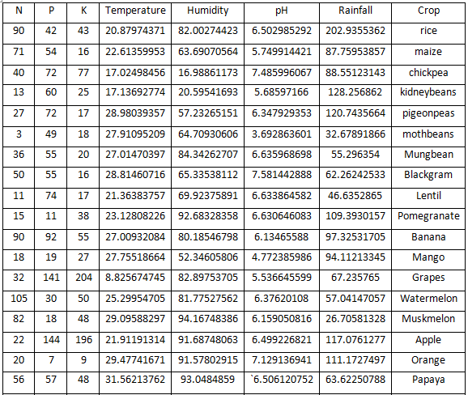

It has the following attributes:

* Nitrogen (N): Part of the "Enormous 3(NPK)" supplements needed by plants for their food. Any plant ingests Nitrogen the most of all nutrients. Nitrogen is fundamental in the development of proteins which are urgent for the development of any plant. Soil Nitrogen esteem is accordingly fundamental in deciding the kind of harvests that could develop there as various yields require a shifting level of nitrogen.
* Phosphorus (P): Second of the “Big 3(NPK)” nutrients required by plants for their sustenance. Phosphorus is used by plants to store energy and also to do photosynthesis. It also aids in plant growth and development so it becomes crucial for any crop. As mentioned for N, soil P values also differ from crop to crop.
* Potassium (K): Third of the “Big 3(NPK)” nutrients required by plants for their sustenance. Potassium is responsible for plant immunity and increasing yield. K helps strengthen root systems in dry/cold conditions. As stated for N & P, every crop needs a different amount of Potassium to thrive.
* pH: pH can be considered an important factor as it affects many other soil attributes and processes that influence plant growth. The behavior of microorganisms, as well as the solubility and availability of nutrients, are all pH-dependent processes so when the pH of the soil is about seven, most crops thrive.
* Temperature: Temperature is perhaps the main variables in cultivating as irregular characteristics in it can prompt demise of harvests, failure of manures among different issues. Right temperature is additionally crucial for give better yield quantitatively and subjectively.
* Humidity: A feature that is indirectly dependent on air temperature thus making it very important for crop production. More humidity tends to cause foliar or root diseases in plants thus increasing pesticide costs and decreasing yield. On the other hand, low humidity leads to slow growth and more leaf drops.
* Rainfall: Another very important environmental feature for crop production. Less of it can starve crops or increase production costs as artificial watering would have to be ramped up. More of it would mean the inundation of crops or dilution of pests and fertilizers making crops vulnerable to diseases.
* Crop: The dataset maps specific crops like rice with the above 7 attributes. Since most crops have a tolerance range in each of the 7 attributes that is why there are multiple entries per crop.

This dataset was used to build the prediction system. This dataset has 22 varieties of crop like rice, watermelon, etc. with 100 entries for each type to get a better model for each crop and thus making the dataset more uniform avoiding any bias due to less data for any specific crop.

* + 1. LOCATION AND CROP BASED DATASET

Table 2.2 Location based dataset

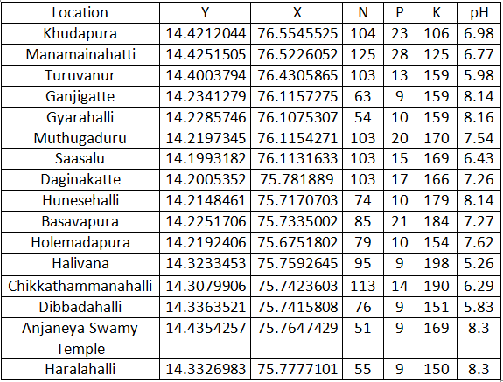

The crop-based dataset and location-based dataset are the other dataset used for the project. The initial aim was to find one dataset that also had location-related information along with soil chemistry and environmental factors related to crops.

pH, Nitrogen (N), Phosphorus (P), and Potassium (K) are the seed parameters that are used to classify the crop. Crop parameters are used to characterize a diverse range of crops grown in India's fertile lands. The soil dataset includes data samples collected from various locations in Chennai and other Tamil Nadu districts.

Table 2.3 Crop based dataset

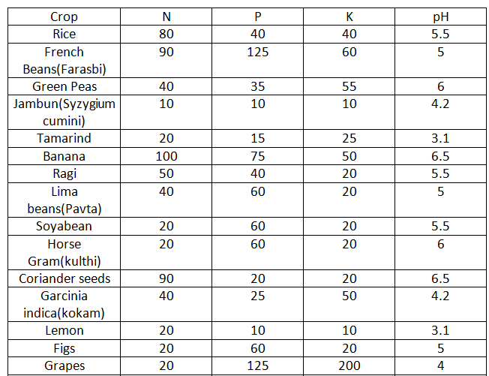

pH, Nitrogen (N), Phosphorus (P), and Potassium (K) is the soil parameters that are used to classify the soil. The data samples were collected from the Tamilnadu-Kancheepuram district's approved horticulture department. To collect feedback from users, the device employs an interface. Depending on the module they choose, the input form can vary.

2.2 CROP PREDICTION

As we all know that crop prediction is of great use to global food production as many of them rely on accurate prediction to make timely import and export decisions and can make both ends meet. The crop prediction starts with importing the dataset from Kaggle and necessary packages and libraries are installed. Heat map is then used to show the correlation between different attributes of a dataset.

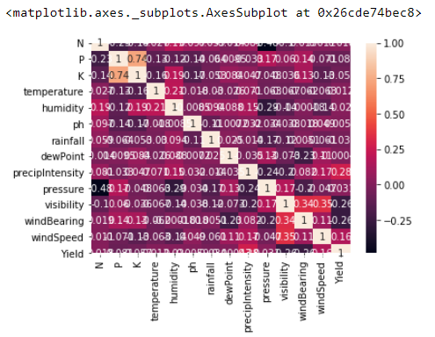

Fig 2.1 Heat map of crop Prediction

Then cleaning the dataset is done in case there are null values present in the dataset.After that Normalization of the dataset is performed using Standard Scaler to increase the efficiency of our ML model. Finally, we have used different machine learning algorithms like DecisionTreeClassifier, GaussianNB, Support Vector Machine, LogisticRegression, and RandomForestClassifier against our dataset to compare the accuracy and the below table showed the same.

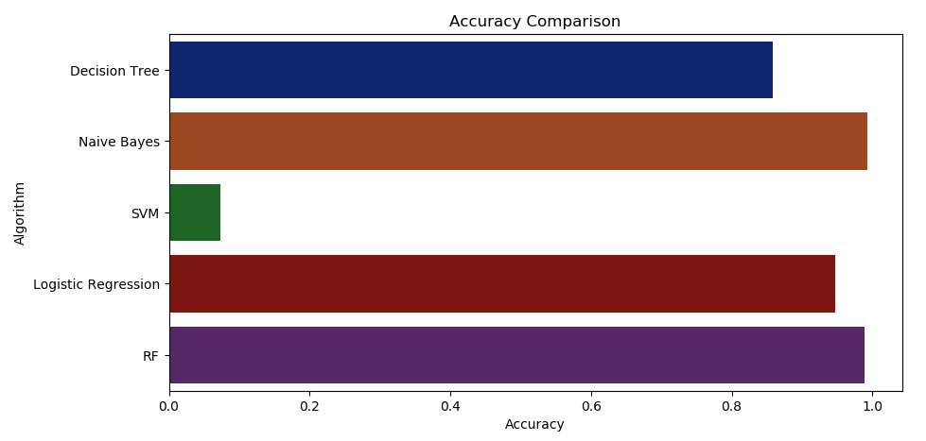

Fig 2.2 Algorithm vs. Accuracy comparison

Now we considered Random Forest as our classification algorithm for further prediction and use the pickle module to save our model. So whenever the user enters the required input through an interface, this model is used to predict the crop and display it to the user.

2.3 CROP RECOMMENDATION

Along with crop prediction, our project also encourages the recommendation of a set of different crops to the farmers based on two methods either via their city location or via their soil nutrients value.Similar work is done for prediction, which involves dataset import, cleaning, and normalizing the dataset, but for crop recommendations, we used k-nearest neighbors*.*

In the first part, when the user inputs his city location through the interface, the given input will be mapped to the location-based dataset to gather the soil parameters of the corresponding city. Then this list of parameters will be mapped to that crop dataset and with the help of the KNN classification algorithm, this list of the parameter will find themselves a suitable class of crop and thus the result is displayed to the user through an interface.

In the subsequent part, the user needs to include soil supplements for crop suggestions. The provided input will be saved in a variable, and the crop dataset will be used to map it. With the help of the K-Nearest Neighbor classification algorithm, the input locates itself into a crop class and the same will be displayed to the user using an interface. Subsequently, the user will get a list of crops suggested by the system.

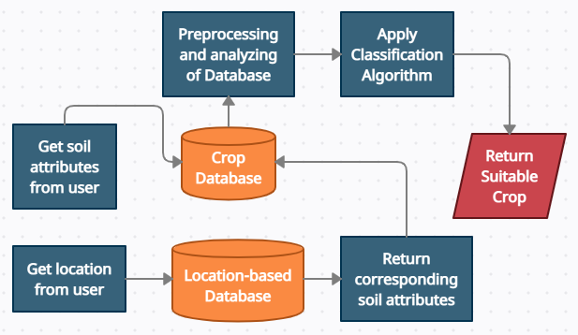

Fig 2.3 System architectural diagram

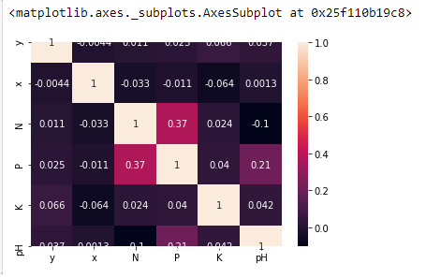

Fig 2.4 Heat map of crop recommendation

2.4 AGRICULTURAL INFOTAINMENT

In contrast to other sectors, there is a lack of well-presented agricultural infotainment. As a result, the project aimed to provide blog-style content that any reader could understand and that would allow them to follow or at the very least be aware of modern agricultural methods. In addition, the system provides the consumer with information on crops, agricultural loans, and available vacant land for cultivation.

This was done by creating HTML pages for each page that can be displayed to the user. The pages were stylized using CSS Bootstrap. The contact information entered by the user, blog posts, and vacant land information is stored in PHPMyAdmin Databases.

2.5 AGRICULTURAL DIAGRAM

The user first needs to have an account to access the application. For that, they need to sign up by filling in some of the personal details and set up strong login credentials. Then they can log in by entering correct credentials to utilize different functionalities accessible. At the homepage, the user enjoys the different blog posts related to topics like agro-education, agro-news, etc. Then the user has crop prediction functionality available in which they can get a single predicted crop after entering the required details in the portal. Also, the system provides a crop recommendation facility in which users can get ten different options of the crop suitable for their soil and location.

Now out of the recommended crops if the user is interested in a particular crop but is unaware of its process of cultivation then he can get that knowledge from the information sector of our application. There he can know about health benefits, climate required, soil requirement, land preparation, planting and spacing, irrigation, manures and fertilizers, harvest, yield, and demand of that crop in the market.

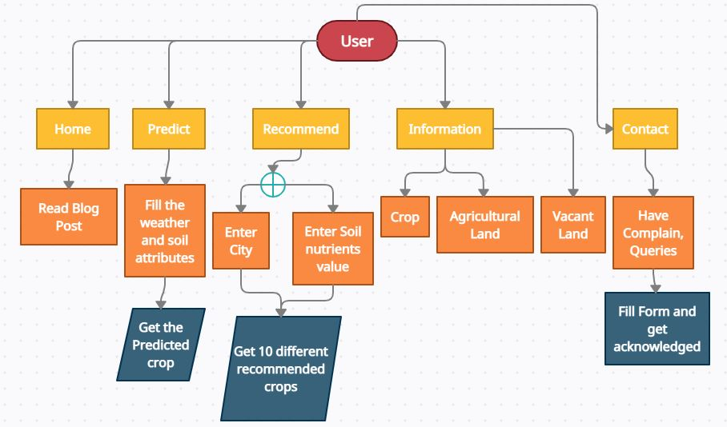

Fig 2.5.1 Architectural diagram of how user uses the system

Even if a farmer needs some loan to fund his seasonal agricultural operation and other activities but is unaware of the process of getting an agricultural loan, he can get information from the Agricultural Loan sector available in the information menu. There he can know about different types of agricultural loans, agricultural loan interest for different banks in India, the process to apply for an agricultural loan, documents required, and eligibility criteria to borrow an agricultural loan.

The system also proved beneficial for peasants as peasants don’t own agricultural land and has to search for that vacant land here and there. So, the system will provide a feature for the user who wants to lend his land for cultivation on a profit basis. The user needs to fill in some details like owner name, description about land, location, and type of peasants which he needs, contact details, etc. Now the system will broadcast this information to all the users including the peasants. So the one who needs this can contact the owner and help themselves.

Finally, after using the application if the user has some query or complaint, he can get in touch with the admin by just filling in a contact form.

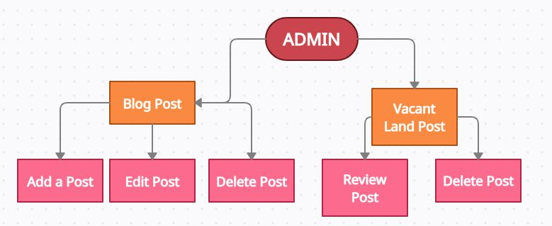

Fig 2.5.2 Architectural diagram of how admin uses the system.

There is an admin panel in which the admin has the privilege to add, edit and delete the blog shown on the user homepage. Also, he can review and delete the vacant land post after getting contacted by the corresponding landowner.

For adding or deleting posts our strategy is simple if the serial number is zero then add all form data as a new post in the database but if the serial number is any other number then edit that number of blogs. To add data to the database we will use the “Posts” class in which we pass the object of SQLAlchemy. We will pass form data through arguments and then add the data to the database through “db.session.add ()”.

**CHAPTER-3**

**Algorithms**

* 1. RANDOM FOREST

As the name suggests, the algorithm mimics a forest as in being composed of arrangements of trees where trees mean decision trees. It is an ensemble dataset and it builds on the algorithms of decision trees to handle more complicated datasets.

It is a supervised model. More trees in a model makes it more robust and thorough and decisions made by this model thus turn out to be more accurate than a lot of other famous ML models.

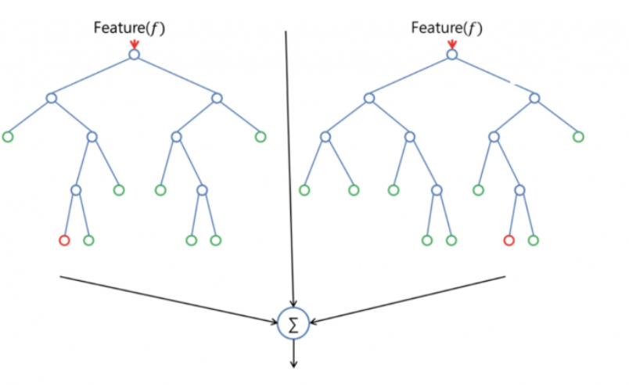

Fig 3.1 Random Forest consisting of multiple decision trees

3.2 K NEAREST NEIGHBOR

This is a supervised model that basically works to categorize new data into groups of already similar data. Thus, it creates a lot of data neighborhood or clusters. This algorithm is used generally for classification problem making it ideal for our project as our project practically deals with predicting crops based on given inputs.

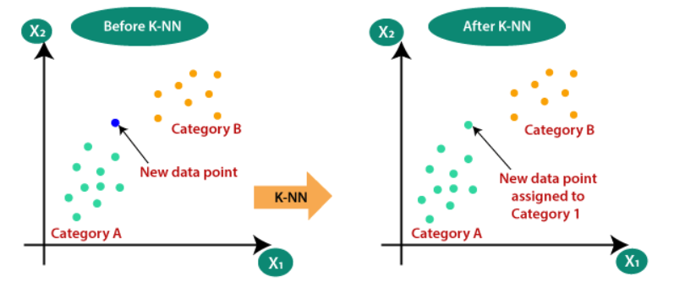

Fig 3.2 K Nearest Neighbor working

3.3 SUPPORT VECTOR MACHINE (SVM)

SVM is a very popular supervised machine learning algorithm. It is multi-purpose as it is used for both classification and regression problems.

In SVM, for a dataset of N number of attributes we plot the data items as points in a N-dimensional space. Then classification is performed on these data points to find the hyper planes that differentiate the various classes.

The main aim of this algorithm is to find hyperplanes with higher margins (distance from each class of data). Higher margins ensure more robustness, reduce ambiguity and provide more flexible range for each class.

In python, simple first layer SVM can be implemented by using scikit-learn’s SVM tool (as used by us in this project too).

As it is with most simplistic and primitive ML models, they start underperforming when dataset has more noise and class distinction gets tough which in turn leads to either hyperplanes with low planes or with more porosity thus reducing overall efficiency of the model.

SVM also suffers badly if the datasets are very large or if number of attributes outnumbers the training data.

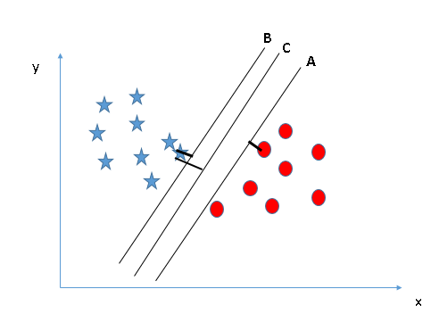

Fig 3.3 Sample SVM with 3 possible hyperplanes (A, B, C) with C being optimal due to higher margin

3.4 GAUSSIAN NAÏVE BAYES(NB) MODEL

This model at its bare bones is a high-level implementation of Bayes theorem (which is used to calculate conditional probability).

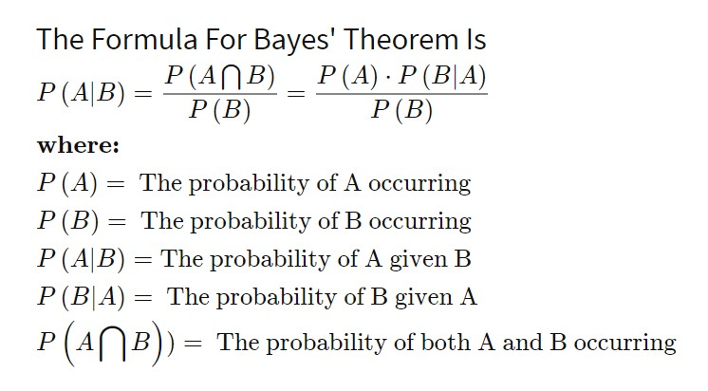

Fig 3.4.1 Bayes Theorem

Bayes theorem has application in other fields also.

Naïve Bayes Classifiers are based on Bayes theorem. They are a set of classifiers which take into assumption that in a dataset each attribute is independent of the other, hence the name “naïve”. They are a supervised learning model and work very well on relatively on small training dataset to provide adequately optimal classification result.

Continuous data are generally assumed to be modeled according to Gaussian distribution.

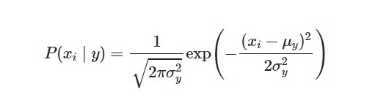

Fig 3.4.2 Probability in Gaussian System

μ- Mean

σ- Standard Deviation

Gaussian NB is one of the most popular NB models used to build ML models.

Here, we build the model by finding mean and standard deviation of the different classes each expressed as a Gaussian distribution on its own and the testing data will be classified based on its closeness to each of these distributions.

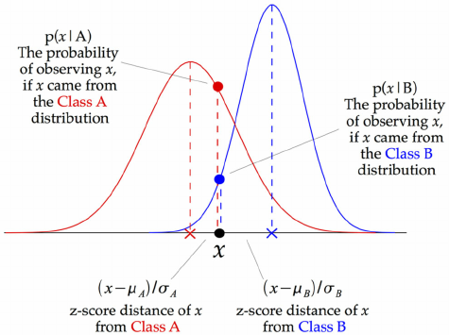

Fig 3.4.3 Graphical Representation of Gaussian NB model

In python, Gaussian NB is implemented by import GaussianNB tool from scikit learn’s Naïve bayes sub library.

GNB suffers from the same pitfall of assuming that attributes are independent of each other. GNB also has the problem of “Zero Frequency” which happens when GNB assigns zero probability to any categorical variable that was not present in the training set.

3.5 LOGISTICS REGRESSION

It is another machine learning algorithm that is derived from the concepts of statistics. Logistic regression is widely used for binary classification.

This model is based on the S-shaped logistic function which is used in varied fields like population growth prediction etc.

1 / (1 + e^-value)

The sigmoid logistic function can be depicted as:

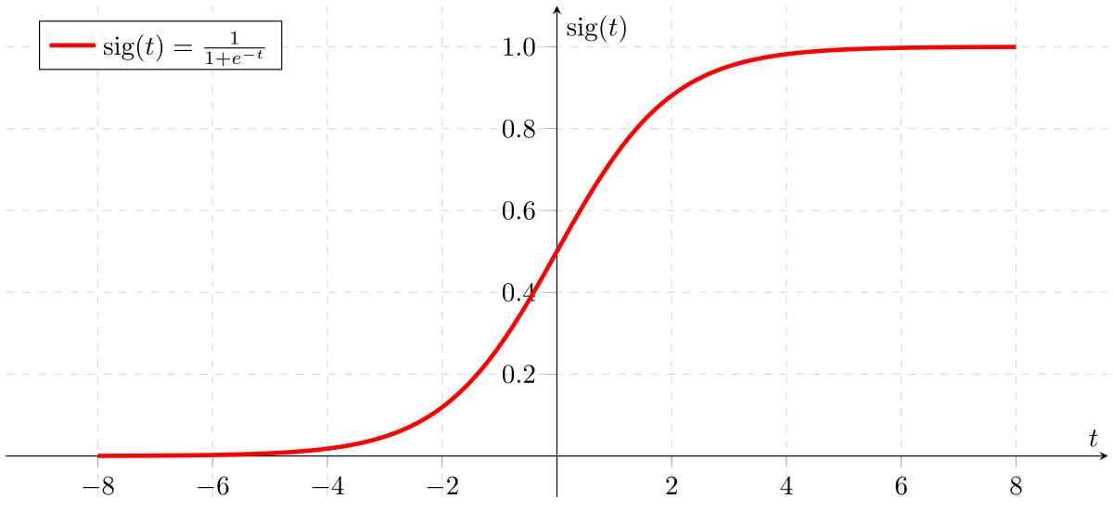

Fig 3.5 Sigmoid function

In this model a dependent variable is labelled as 0 or 1 and the co-mingling of the independent attributes forms a log-odds plot to depict data point’s closeness to either 1 or 0.

In python, we use scikit learn’s inbuilt model to do logistic regression.

Logistic regression does not work well when it has to handle large number of categorical variables.

**CHAPTER-4**

**Tools and Libraries**

4.1 render_template

The flask.templating package contains the render template Flask method. The render template function is used to generate output from a template file that is based on the Jinja2 engine and located in the application's templates folder.

Note that instead of flask.templating, render template is usually imported straight from the flask package. It's the same function that's imported, but without the templating component, there are fewer characters to type.

4.2 request

The Flask application produces a Request object depending on the environment it obtained from the WSGI server when it processes a request.

4.3 session

The Session is the period of time between when a client logs in and logs off of a server. The data that must be saved in the Session is saved on the server in a temporary directory. The data in the Session is saved on top of cookies and is cryptographically signed by the server. Each client will have their own session, with their own data stored in it.

4.4 redirect

The redirect () function is available in the Flask class. It returns a response object and redirects the user to a different destination location with the provided status code when it is invoked.

4.5 url_for

The Flask flask.helpers module contains the function url_for. url_for uses the method supplied in as a parameter to produce a URL for an endpoint.

Even though it is defined in the helpers module, url for is usually imported directly from flask rather than flask.helpers. It's the same function that's imported, but without the.helpers section, there are fewer characters to type.

4.6 flask-sqlalchemy

It seeks to make using SQLAlchemy with Flask easier by providing useful defaults and other utilities that make common tasks easier.

4.7 label encoder

Label encoding is a straightforward and straightforward method. Each value of a categorical column is converted to a numerical value using this method. Label is the name given to each value in a category column.

4.8 sklearn neighbors

The k-nearest neighbours technique is implemented in the sklearn.neighbors module, which provides capability for both unsupervised and supervised neighbors-based learning methods.

4.9 Jupyter Notebook

Jupyter allows one to break programs into smaller blocks to make it more human readable and neat. It also contains Markdown and in-built LaTeX capabilities thus making the code for interactive and self-explanatory.

Jupyter finds use in various domain and across various engineering and scientific backgrounds.

4.10 Spyder

Our backend code (described in detail in chapter 2.5) was done on Spyder environment.

Spyder is a non-proprietary and free Python based environment made for the use of engineers and researchers in the field of data science.

Spyder contains editors along with iPython console, debuggers and one of the best on environment help section making it one of the preferred choices to build cross platform python-based applications.

4.11 Flask

It is one of the most popular web application frameworks for python. It is based on toolkits like Werkzeug and WSGI. These toolkits also help in making an interface between web server and web application.

Flask does not enforce any dependency but rather it offers suggestions and this allows us to be more flexible with what tools and libraries we intend to incorporate project.

A major reason for choosing Flask over Django, the other popular python web development framework is that Flask provides rapid development and allows for rapid scalability.

Flask also lends support for API whereas Django does not. Flask allows diversified working style but Django does not.

One major drawback of Flask is that is does not support Dynamic HTML pages but Django does.

However, despite the above-mentioned drawback, Flask is highly popular among developers because of its sheer scalability and flexibility.

4.12 NumPy

NumPy is a very important python library that is used to deal with arrays and do complex computation on them. Capabilities to handle linear algebra, necessitates data scientists to use NumPy arrays instead of the generic list.

4.13 Pandas

Pandas is again another important python library especially useful when dealing with datasets as it can analyze, clean, visualize datasets.

Pandas help in making sense of big messy data which makes it very useful for data analysis of real-world datasets.

Pandas builds on NumPy in that it also uses 1D arrays (called Series here) and matrix type arrays (called DataFrame here) for effective data processing.

4.14 Scikit Learn

Probably the single most important library of Python for Data science. Scikit learn builds on libraries like NumPy, Pandas to provide a library that can do things like clustering, classification, cross validation and parameter tuning.

It is also used to build basic models using pre-existing algorithms like Logistic Regression, Random Forest etc.

4.15 Matplotlib

This is a plotting library mainly used in conjunction with NumPy library. It is based on GUI toolkits like Tkinter, Qt, GTK etc. Matplotlib is meant to provide a MATLAB like interface for Python developers.

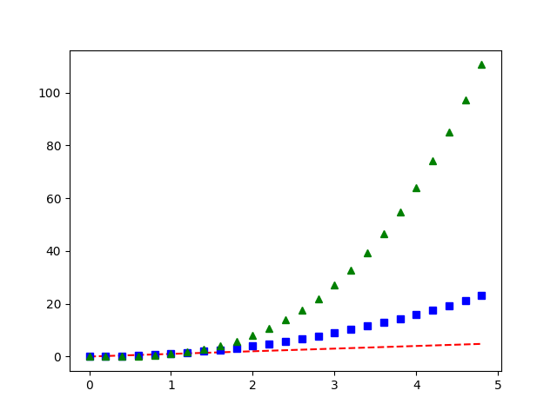

Fig 4.15 Sample plot using Matplotlib

**CHAPTER-5**

**RESULTS AND DISCUSSIONS**



Fig 5.1 Register page

If a user wants to get access to our application, he/she has to first register or create an account by mentioning some of his personal data.



Fig 5.2 Login page

After creation of an account, the user can login by entering correct credentials.

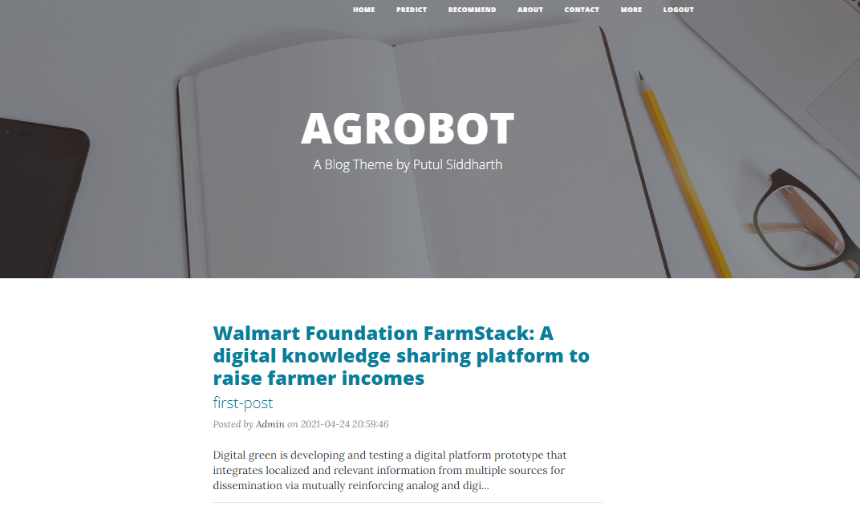

Fig 5.3 Homepage

The Homepage consist of blogs related to agro-education, agro-news etc.

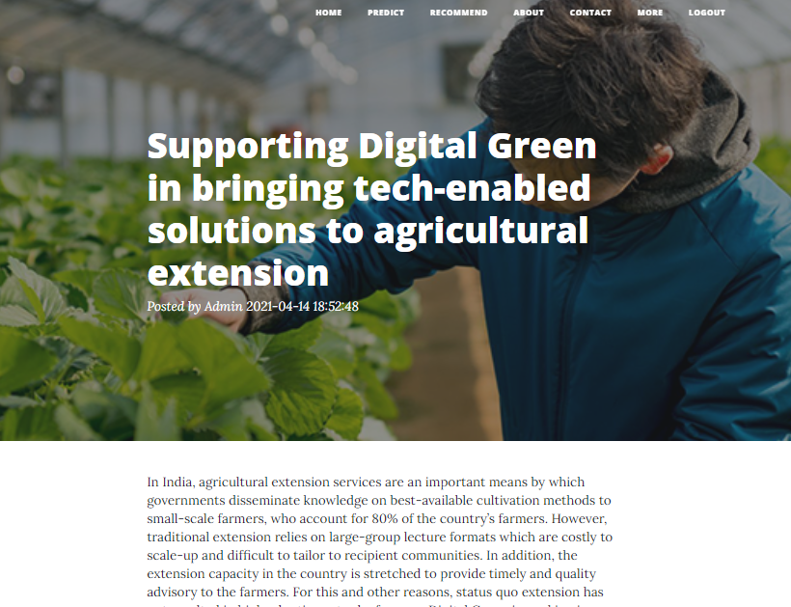

Fig 5.4 Blog post

The figure shown above is a sample blog post related to “Digital Green India”.

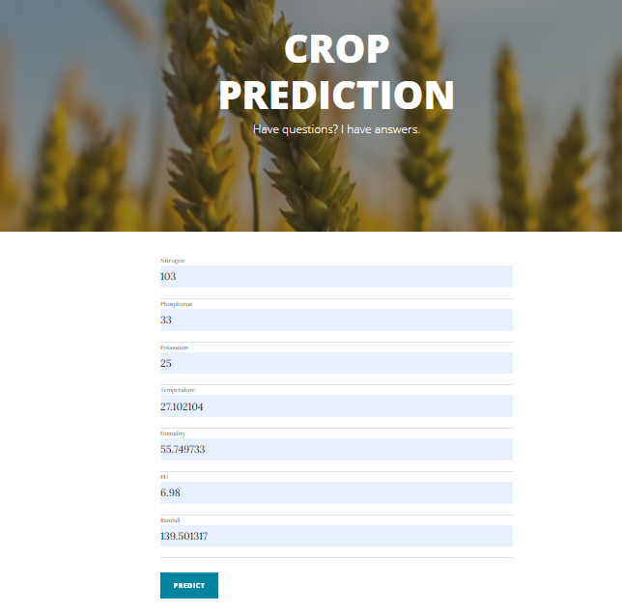 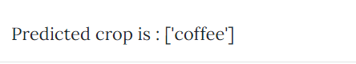

Fig 5.5 Crop Prediction

Using Random forest as our classification algorithm, a prediction system was built. The datasets used were not as extensive as was expected however they were unbiased towards any specific crop because each of the 22 crops had 100 data instances each. After analyzing different ML algorithms, Random forest was chosen as it gave 98.93 percent accuracy.

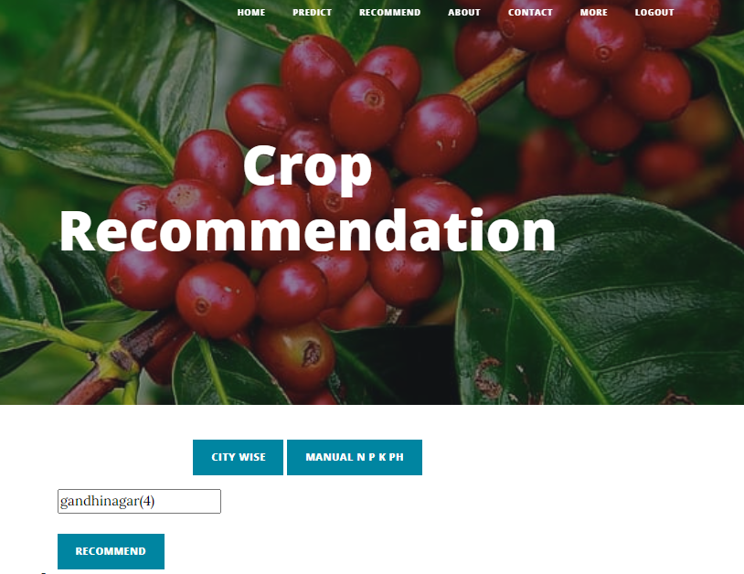

Fig 5.6 Crop recommendation based on location

For the recommendation system, 10 different suggestions were generated for each entry using the KNN classification algorithm. “predict_proba” function of MultiOutputClassifier was used for this.

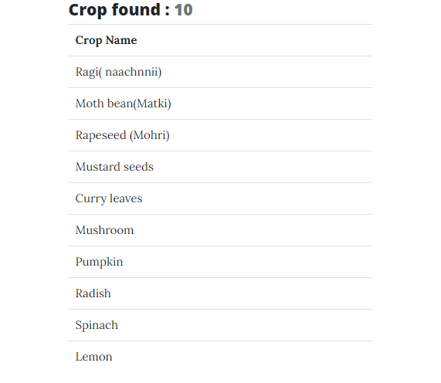

Fig 5.7 Listed crops based on recommendation

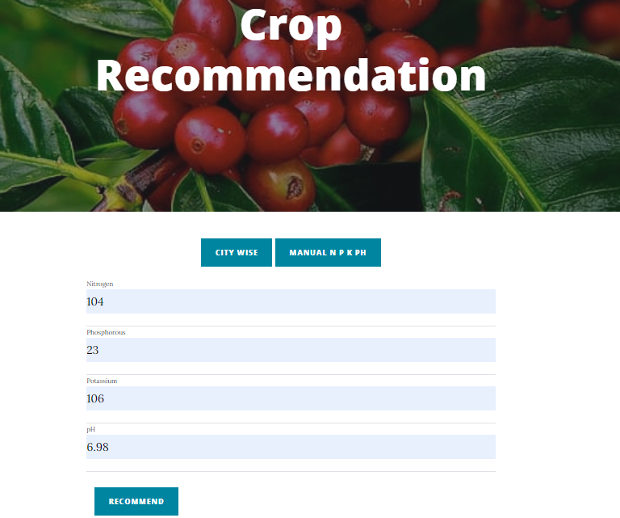

Fig 5.8 Crop recommendation based on soil nutrients attributes

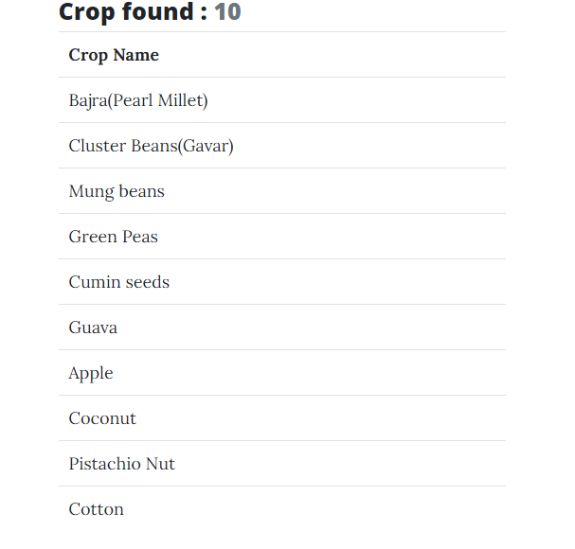

Fig 5.9 Listed crops based on recommendation

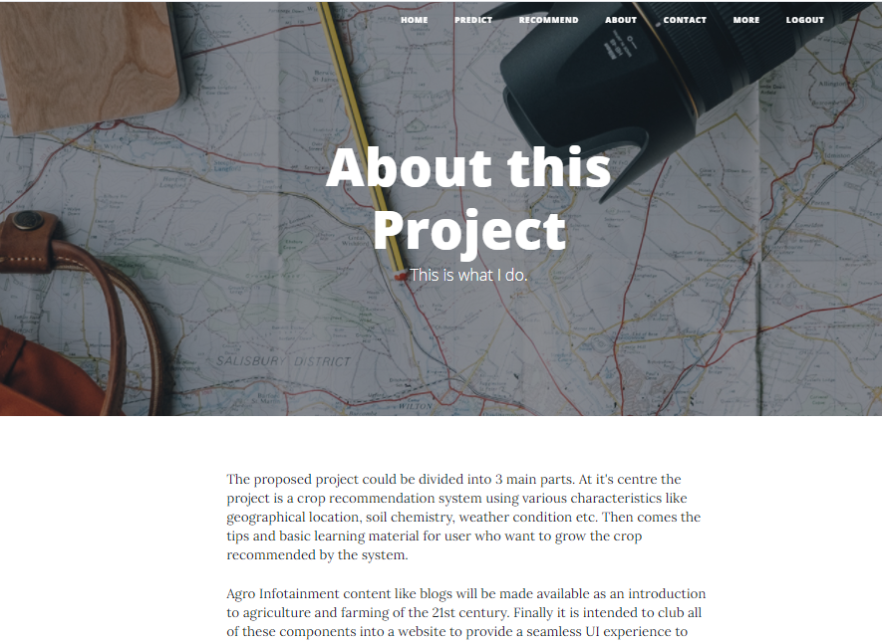

Fig 5.10 About page

This page tells us “what we are doing actually”.

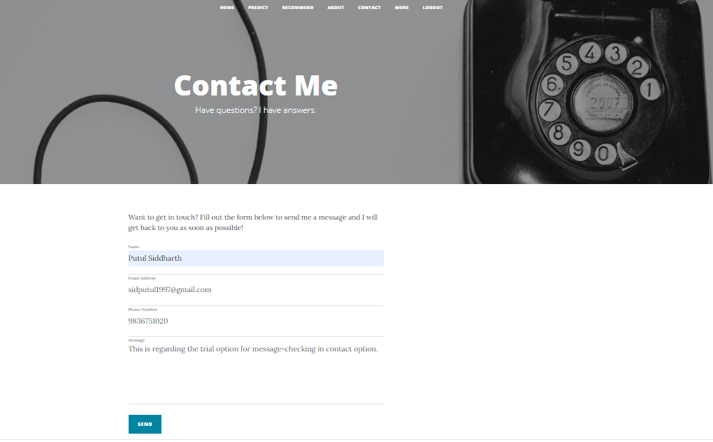

Fig 5.11 Contact page

If the user has any complain or queries regarding app or want to get in touch with the admin, he can fill the form and get acknowledged.

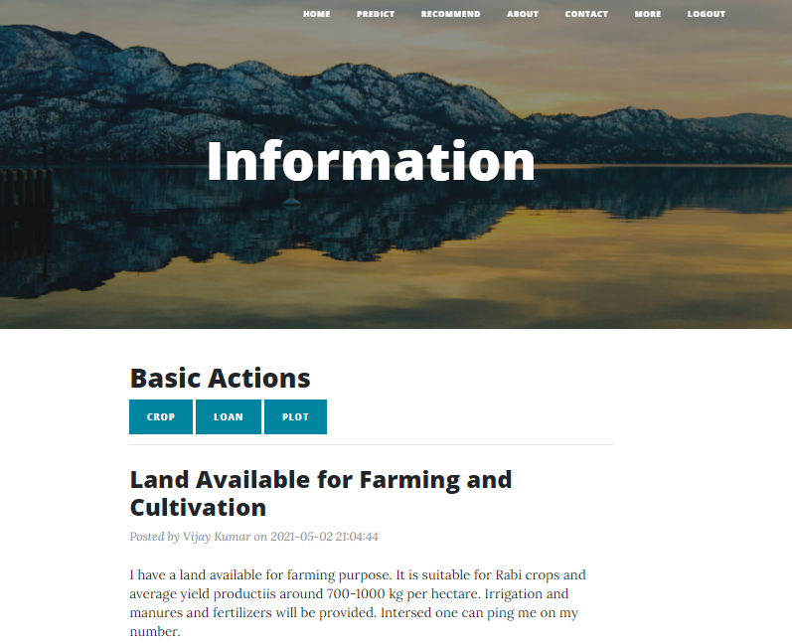

Fig 5.12 Information page

This page is the source of information for crops, agricultural loans, and available vacant land for farming and cultivation purposes. Any user can raise the demand of peasant from here or any user can get in touch with him by seeing the plot blog post.

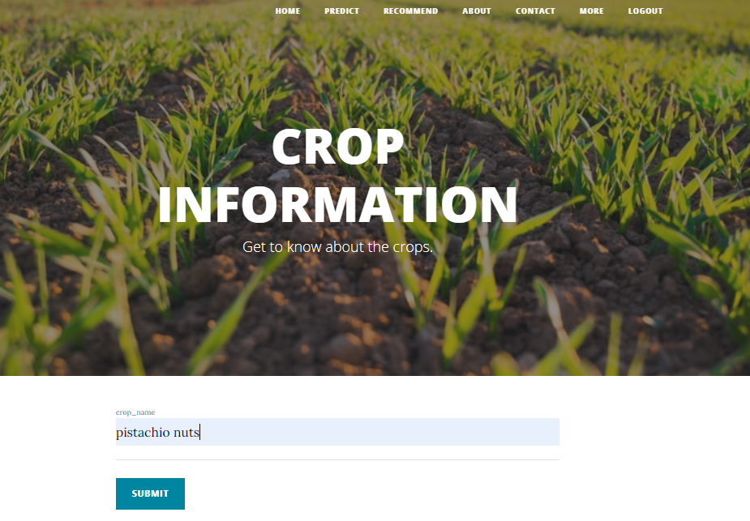

Fig 5.13 Crop Information

The user can come to know everything related to crop from this portal.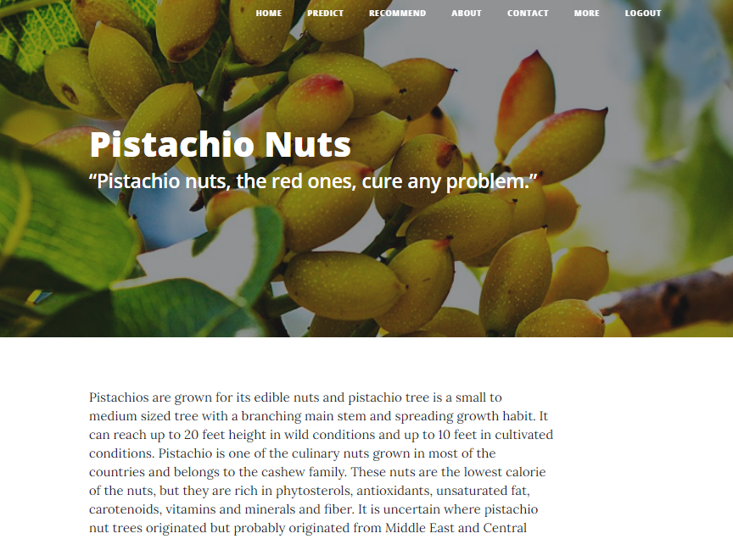

Fig 5.14 Sample crop information

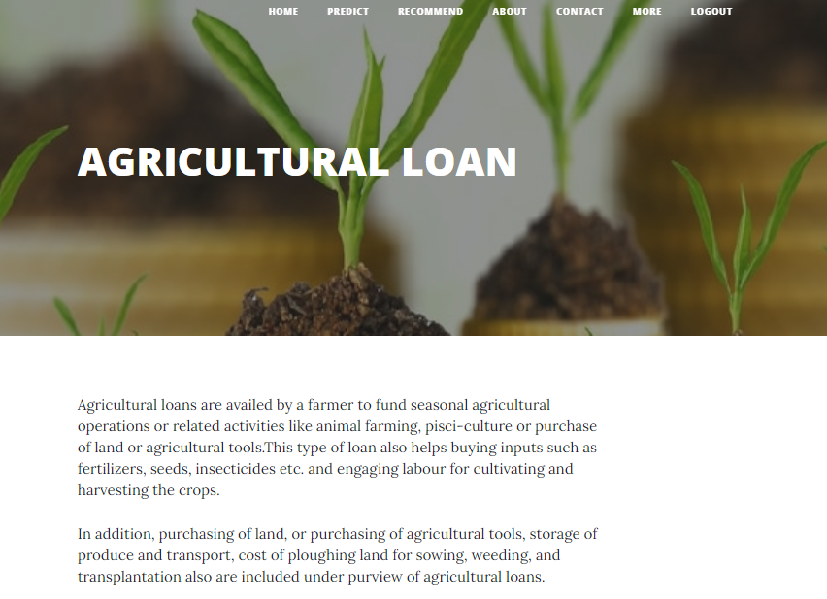

Fig 5.15 Agricultural loan

If a user wants to know about procedure of applying agricultural loan, types of agricultural loan, requirements for applying a loan etc. everything he can get in this portal.

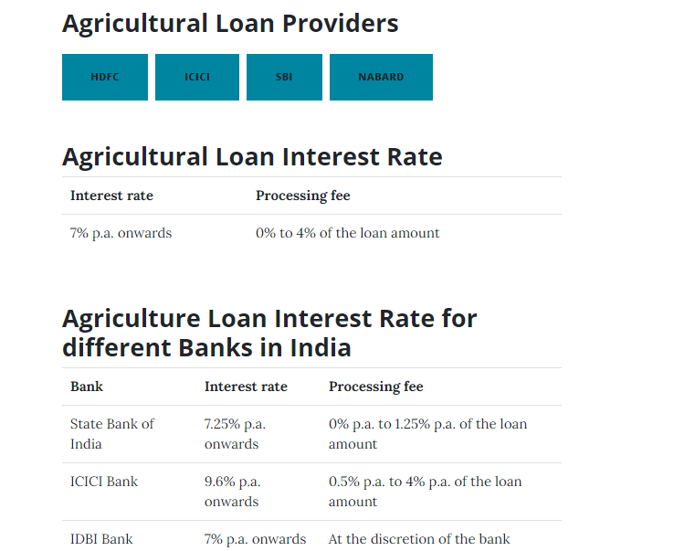

Fig 5.16 Agricultural loan Interest rate and their providers.

The above figure shows the interest rate and processing fee of each of the agricultural loan providers.

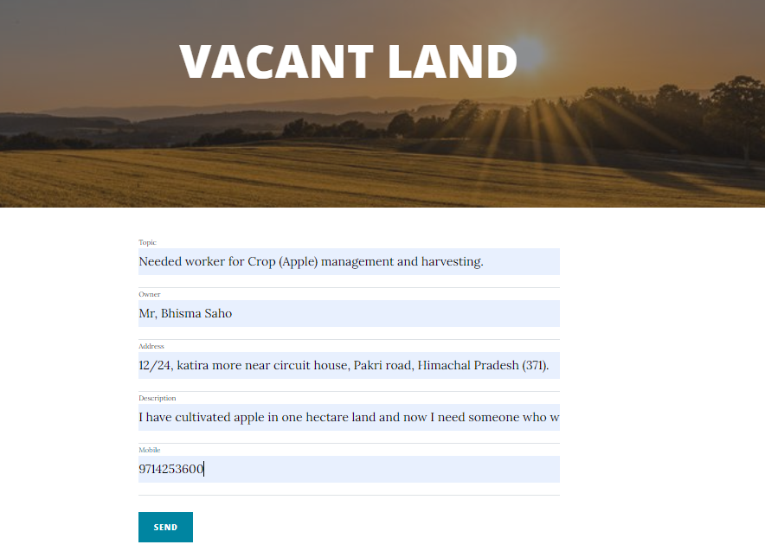

Fig 5.17 Vacant land portal

If any person wants a worker or peasant for his land, he can fill the form here and his details will be broadcasted to every user in form of blog-style.



Fig 5.18 Admin Login

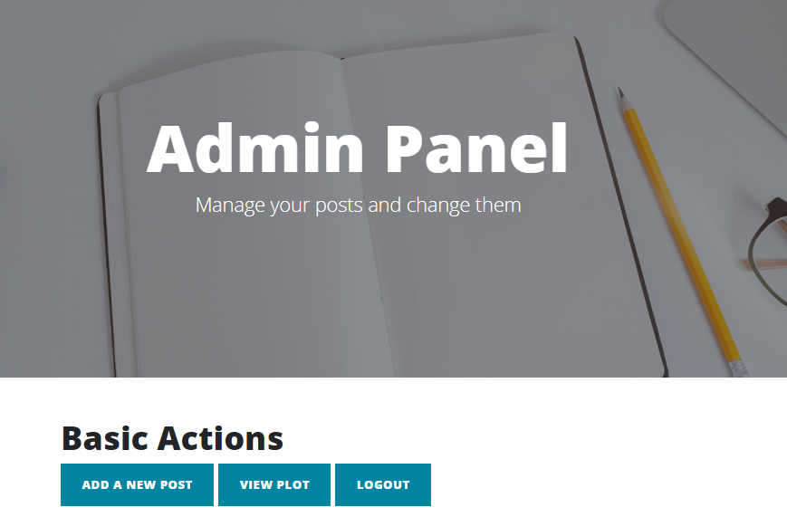 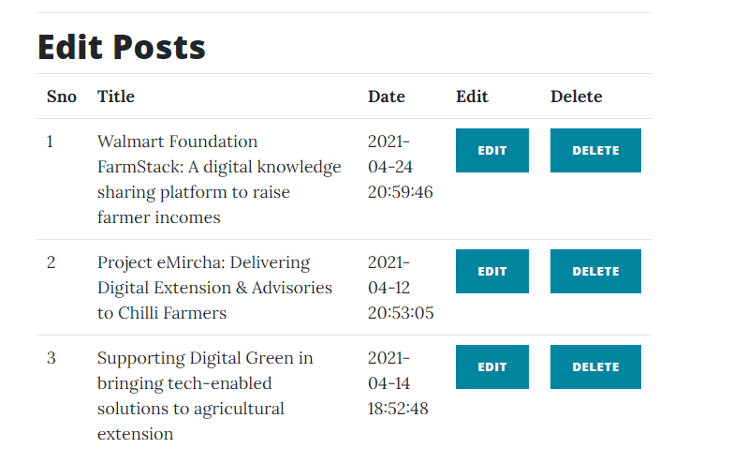

Fig 5.19 Admin panel

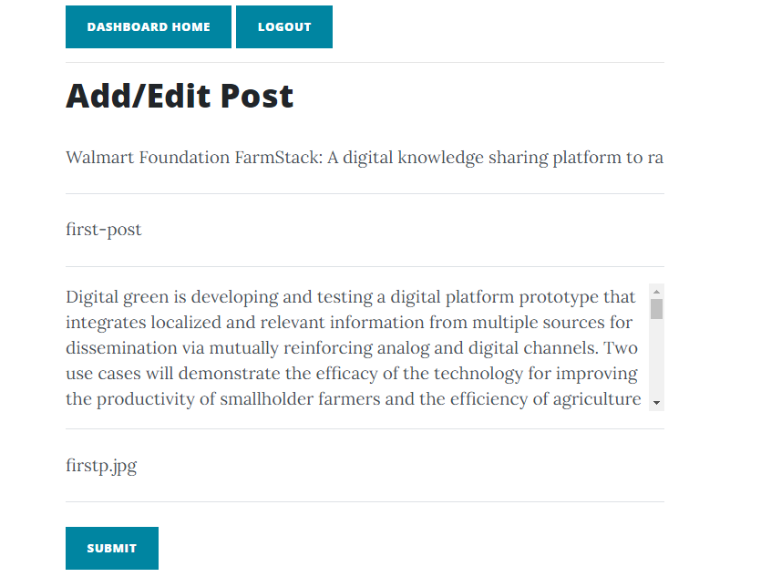

Fig 5.20 Add/Edit Post

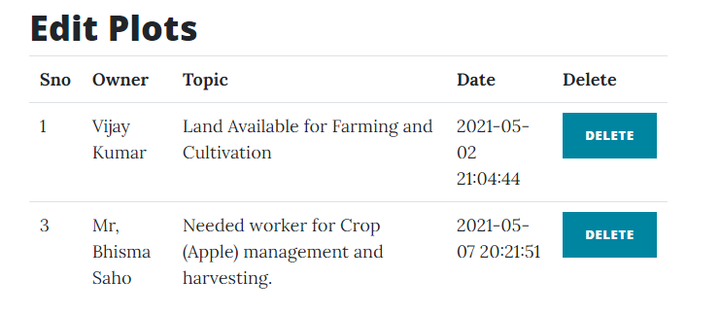

Fig 5.21 Edit Plots

The PhpMyAdmin is a graphical user interface application whose main functionality is managing SQL databases. It can be used for variety of purpose like creating, altering, browsing and deleting databases, views, tables and indexes. It can also be used to create user defined function (stored procedures) for code reusability and can display multiple result and queries.

In our project we have created a database named codingthunder and inside it we have created 3 tables Contact, Post and User. The Post table contains blog posts related to agriculture and crops. The Contact table stores all the query related information sent by the users visiting our website. The User table stores the complete payment details regarding buying of crops. PhpMyAdmin allows the feature to control the user’s permission so database is very secure and encapsulated from unauthorized access. Another advantage is that it needs a localhost port to run, hence all-time internet availability is not needed.

To connect this PhpMyAdmin to my backend flask application, python provides a very handy package named SQLAlchemy. By using Model class of this package, any table can be imported from PhpMyAdmin to the flask application and we can set and retrieve values to and from the respectively desired tables.

We simply need to create parameterized constructor (object creation) of each of these tables before utilizing them in our program.

The database named as “CodingThunder” consist of four table namely accounts, contacts, plots, and posts.

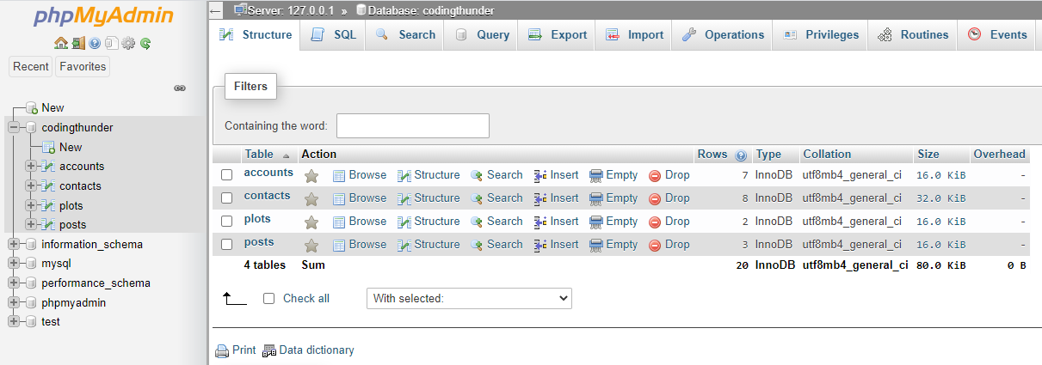

Fig 5.22 Database CodingThunder

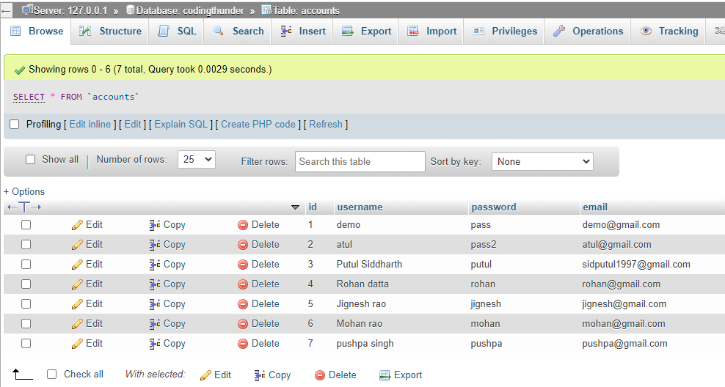

Fig 5.23 Accounts table

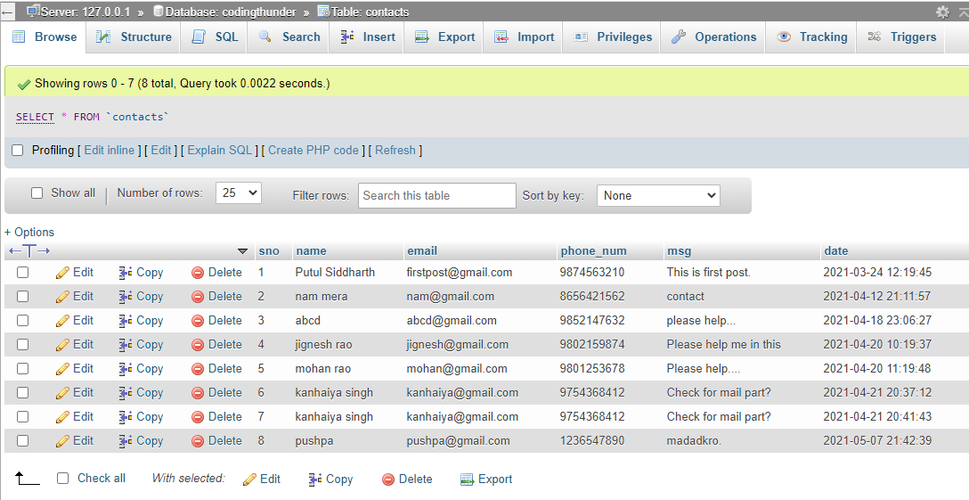

Fig 5.24 Contacts table

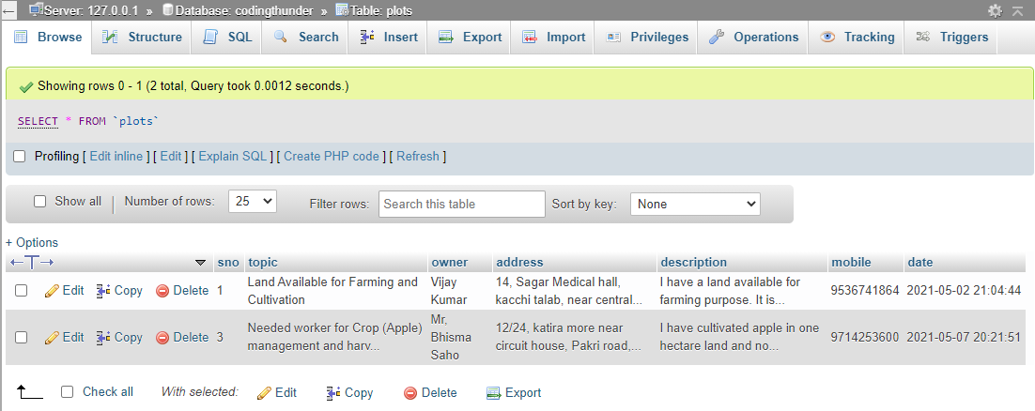

Fig 5.25 Plots table

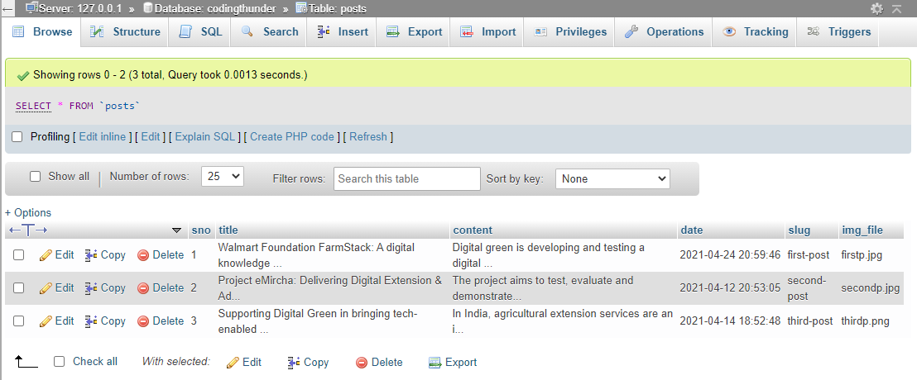

Fig 5.26 Posts table

**CHAPTER-6**

**Conclusion and Future work**

6.1 CONCLUSION

The recommendation system was created upon a sub-optimal dataset. We are trying to improve the dataset by collecting more data. We are also trying to include parameters so that the dataset mimics the real world much better. Including parameters like crop yield (both by weight and by money), crops grown before on soil will make the dataset more robust. For now, the ml model works with acceptable accuracy. Due to Covid-19, the lockdown has been imposed all over the country and people are not in a state to move outside their house. So this recommendation system will be able to help farmers to choose the crops to grow with more precision instead of going to any agricultural center to gain information so that they can avoid losses and maximize profits. By the creation of the E-commerce site, I hope casual readers will become interested in agriculture and will thus help in making farming scientific and efficient.

6.2 FUTURE WORK

Using a better dataset with more parameters and instances to get a more robust model. We will also try to use a dataset that will help us having to use 2 datasets and instead have all parameters in one. We also aim to host the website with robust backend databases to handle traffic and update blogs to keep the site up to date.

6.3 COST ANALYSIS

The project is made with various software tools and all the software used for the project prototype is open source so there is no cost associated with the development of the project.

However, the deployment of the website would cost in following ways:

A database management service is required as our project works on databases and we need to update and scale it in future for the required results. A dedicated plan on a database management service can cost up to Rs. 4000 per month which will provide us with storage capacity of 10GB to 4TB for storing our data, RAM capacity of 2GB to 768GB. In this plan, elastic scalability is provided which allows us to scale our data as and when required. It is also auto scaled that is it can scale the data automatically as well if required. The plan also ensures point-in- time data recovery which gives us the excess to recover our data any point of time.

For deployment of website, we need a subscription for various services which will cost around Rs. 400 per month. The required services involve website security with secure sockets layer, a custom domain connection which gives a name to the website. This plan also includes on-the-go editing which allows us to edit our website anytime. With all these technical services we also receive marketing services as well such as 24/7 support system which keeps our website up and running, guidance and analytics on the stats of the website. We get search engine optimization which ensures our website comes in the view of the person searching for on a search engine.

**APPENDIX**

Importing the necessary packages which will be used in the project

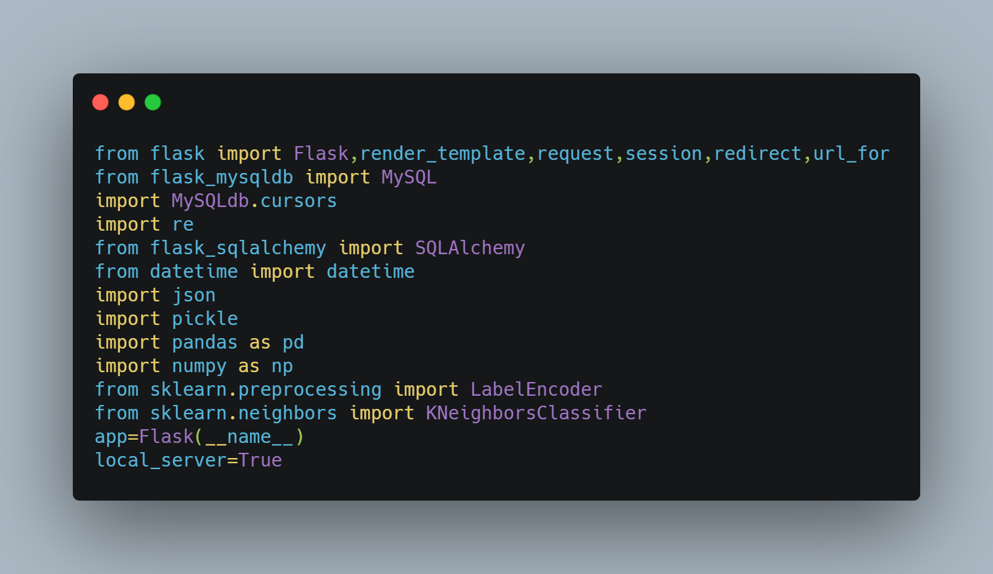

For the prediction of crops, we will be unpickling the Random Forest machine learning model and store it in model variable. mappernew is the dictionary that maps crop to its respective index. The citywise location details are stored in the variable cityfile.

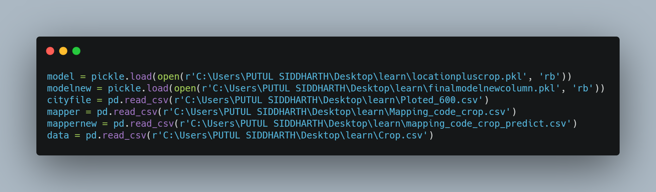

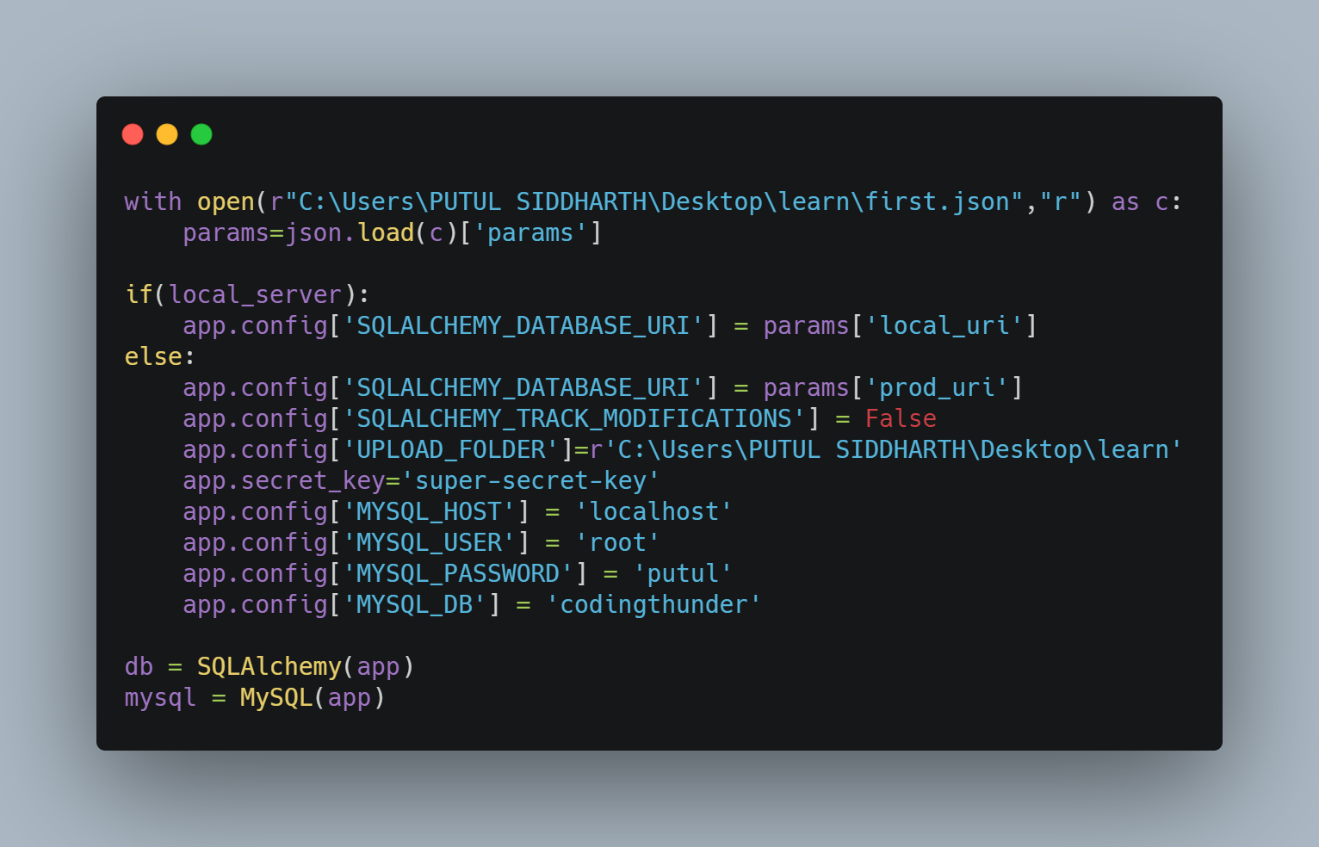

first.json that contains personal credentials (like phpMyAdmin username and password) and links to various social media handles. SQL alchemy object is created to link our flask application with the phpMyAdmin database.

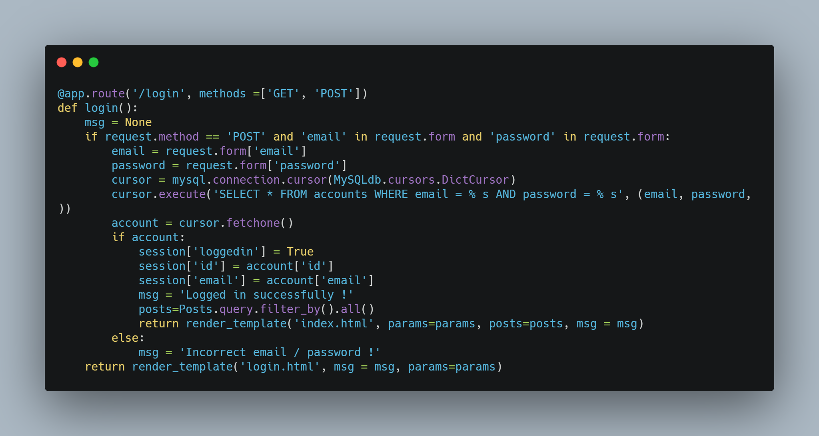

Login function checks whether the credentials entered by the user are correct or matched with the database or not. If it is, then he can enter into the application otherwise a flash message indicate “Invalid email / password !”.

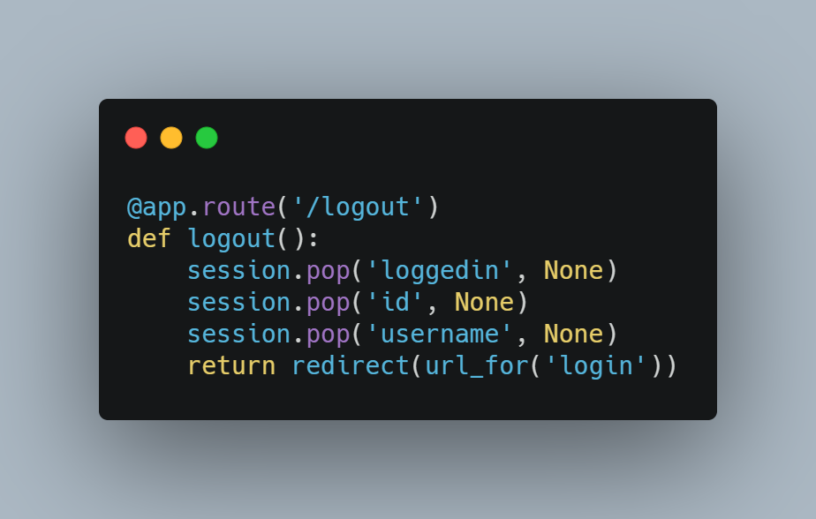

Logout function is created to facilitate user in signing out from his account and redirecting back to the login page.

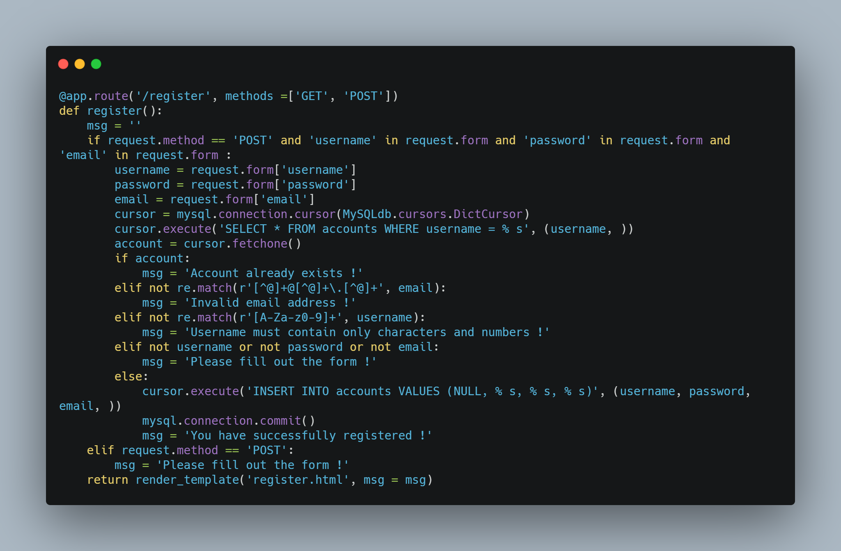

Register function is created to facilitate user to create account on our application. While creating account it will check all the necessary parameter and raise the flag if the user don’t follow the instruction.

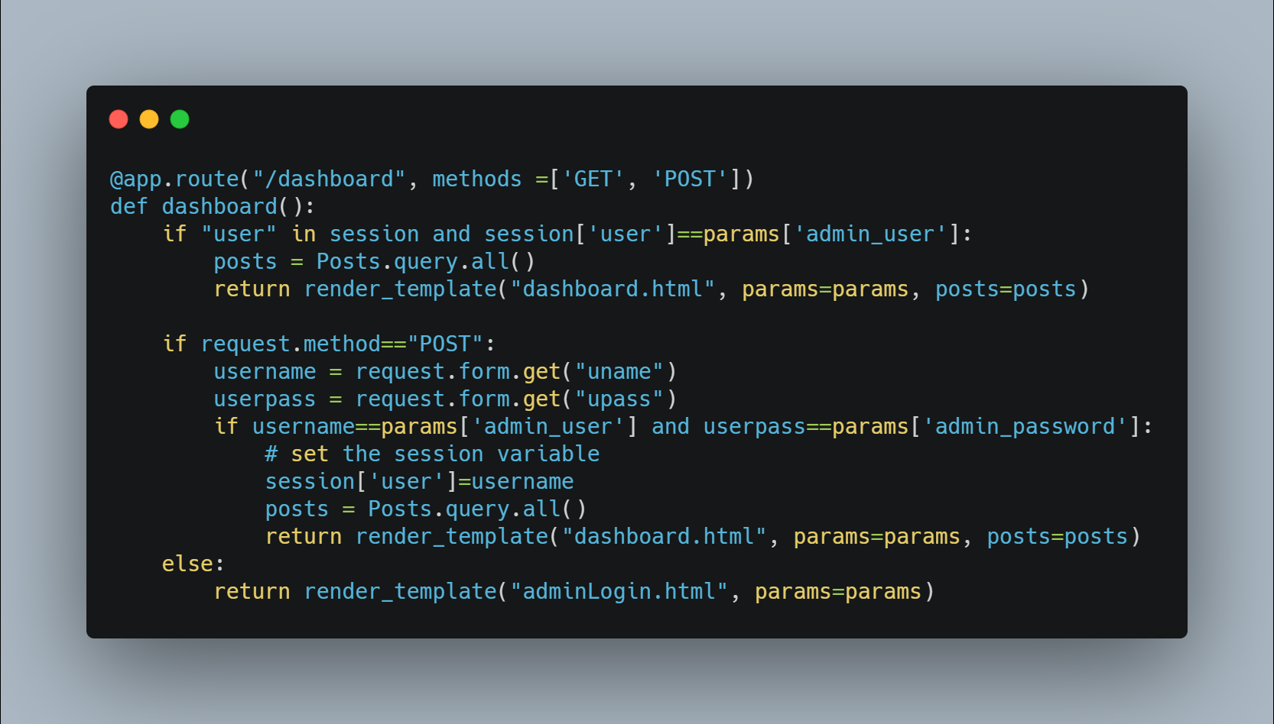

Dashboard function is created to facilitate admin to login into the portal by matching correct credentials from json file.

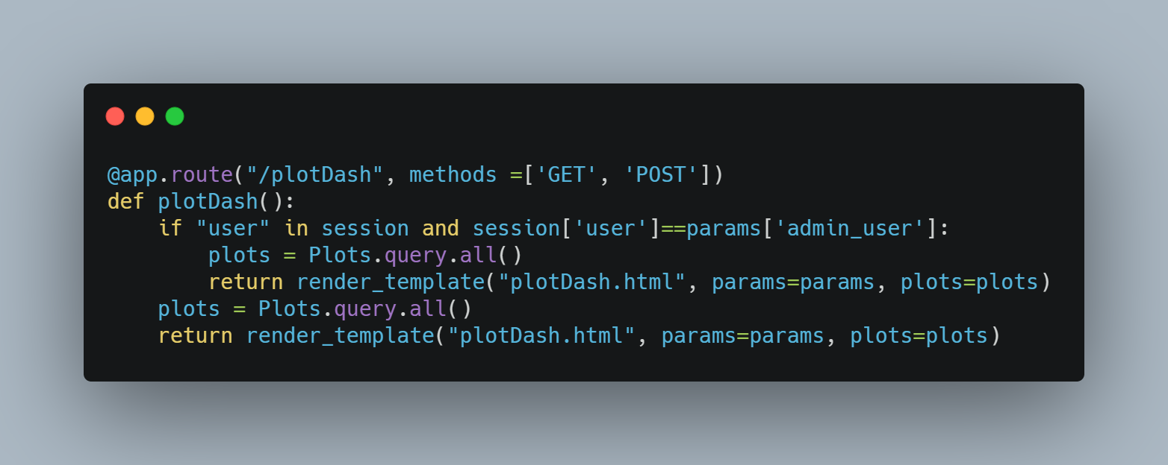

plotDash function is created to redirect user to plot dashboard in which he can see all the plots in form of blog posted by different user.

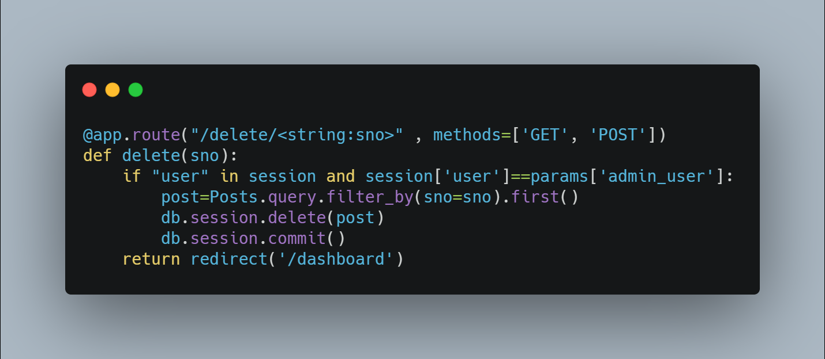

Function used to delete the post corresponding to that serial number.

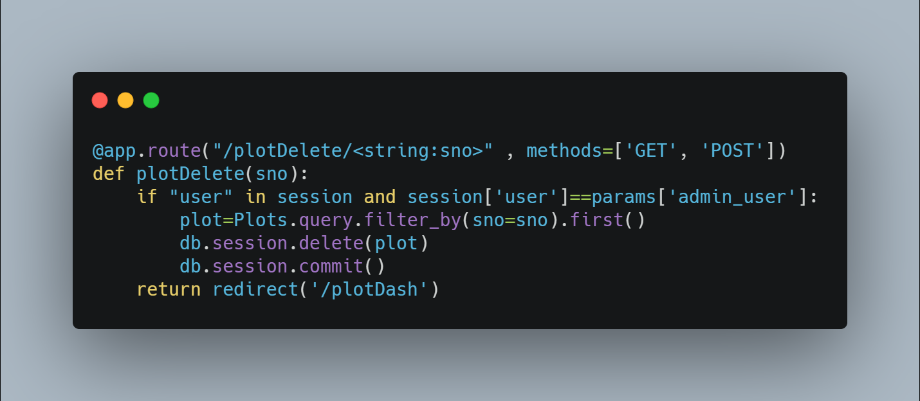

Function used to delete the plot corresponding to that serial number.

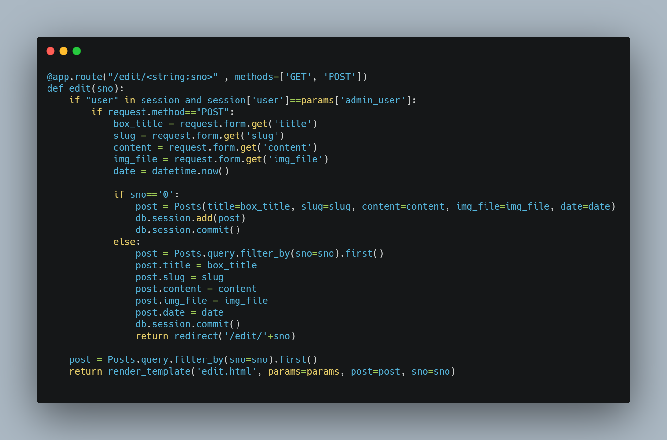

Function used to add or edit the post based on the serial number provided. If the serial number is zero means the post needs to be added along with other post. Otherwise the post is edited and redirected to the edit page.

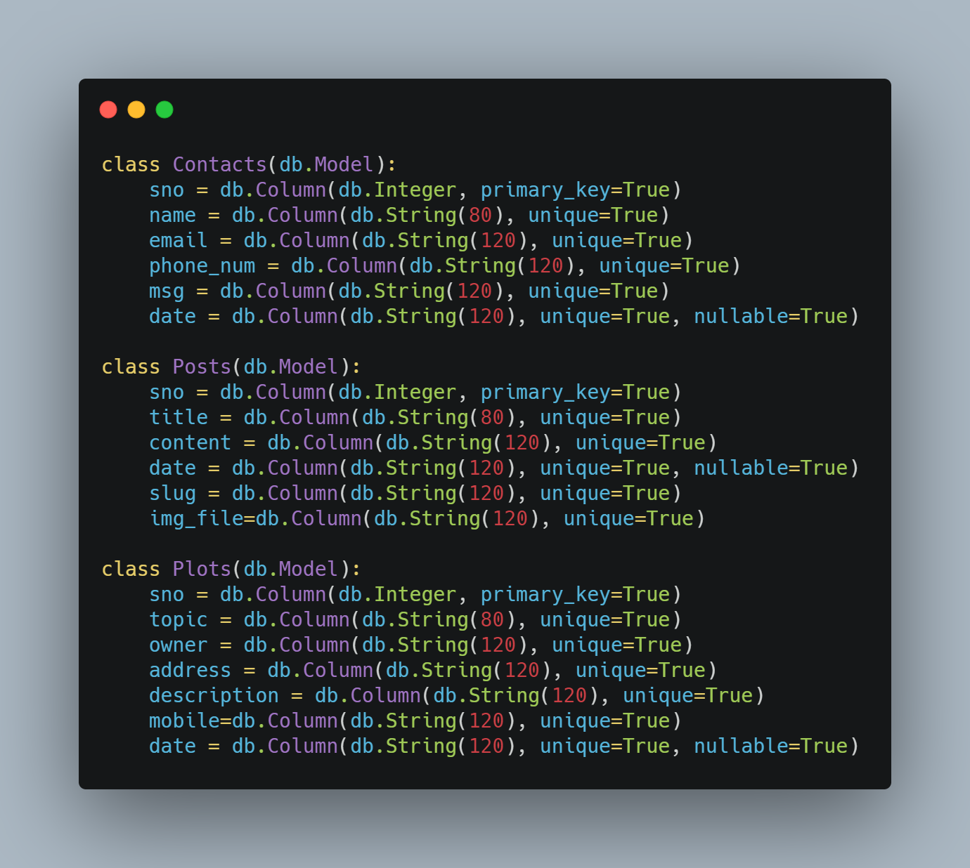

These classes are created to add the value to their respective table in the database.

Contact table attributes are: sno, name, email, phone_num, msg, date.

Posts table attributes are: sno, title, content, date, slug, img_file.

Plots table attributes are: sno, topic, owner, address, description, mobile, date.

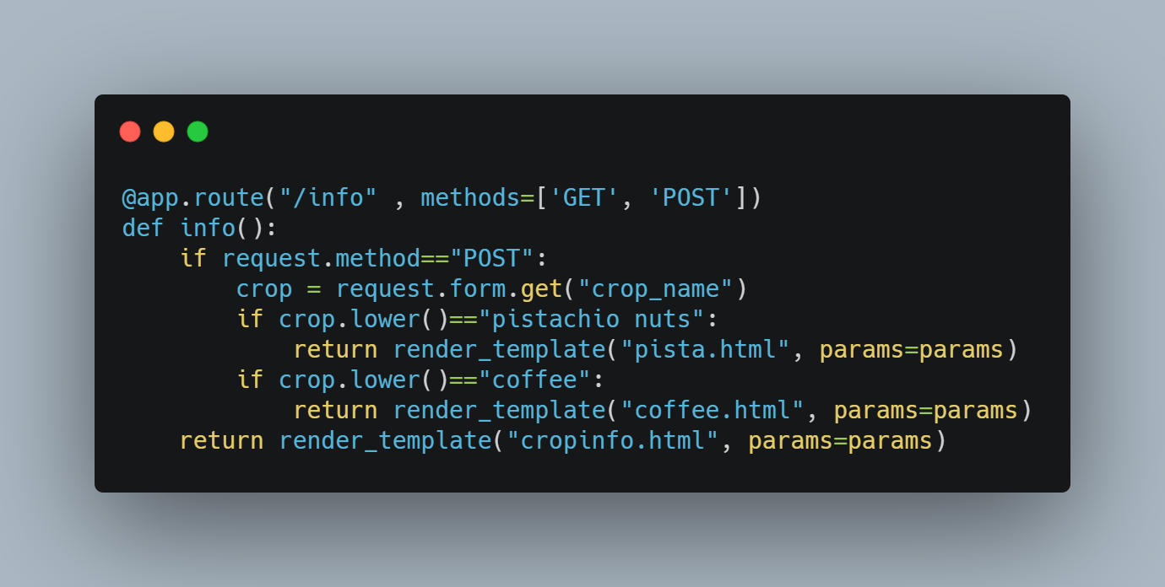

Function is used to take crop name from user as an input and redirect him to that respective informative page.

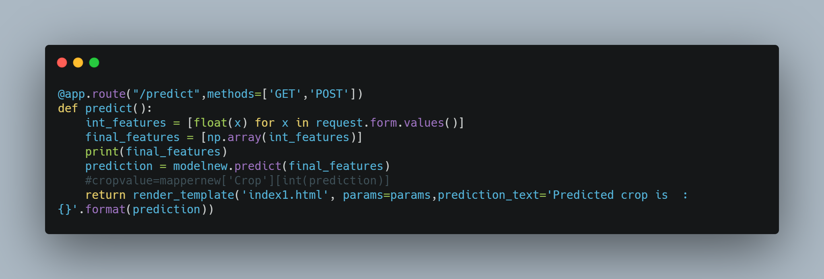

Function used to predict the crop after taking all the soil and weather parameter from the user as a parameter.

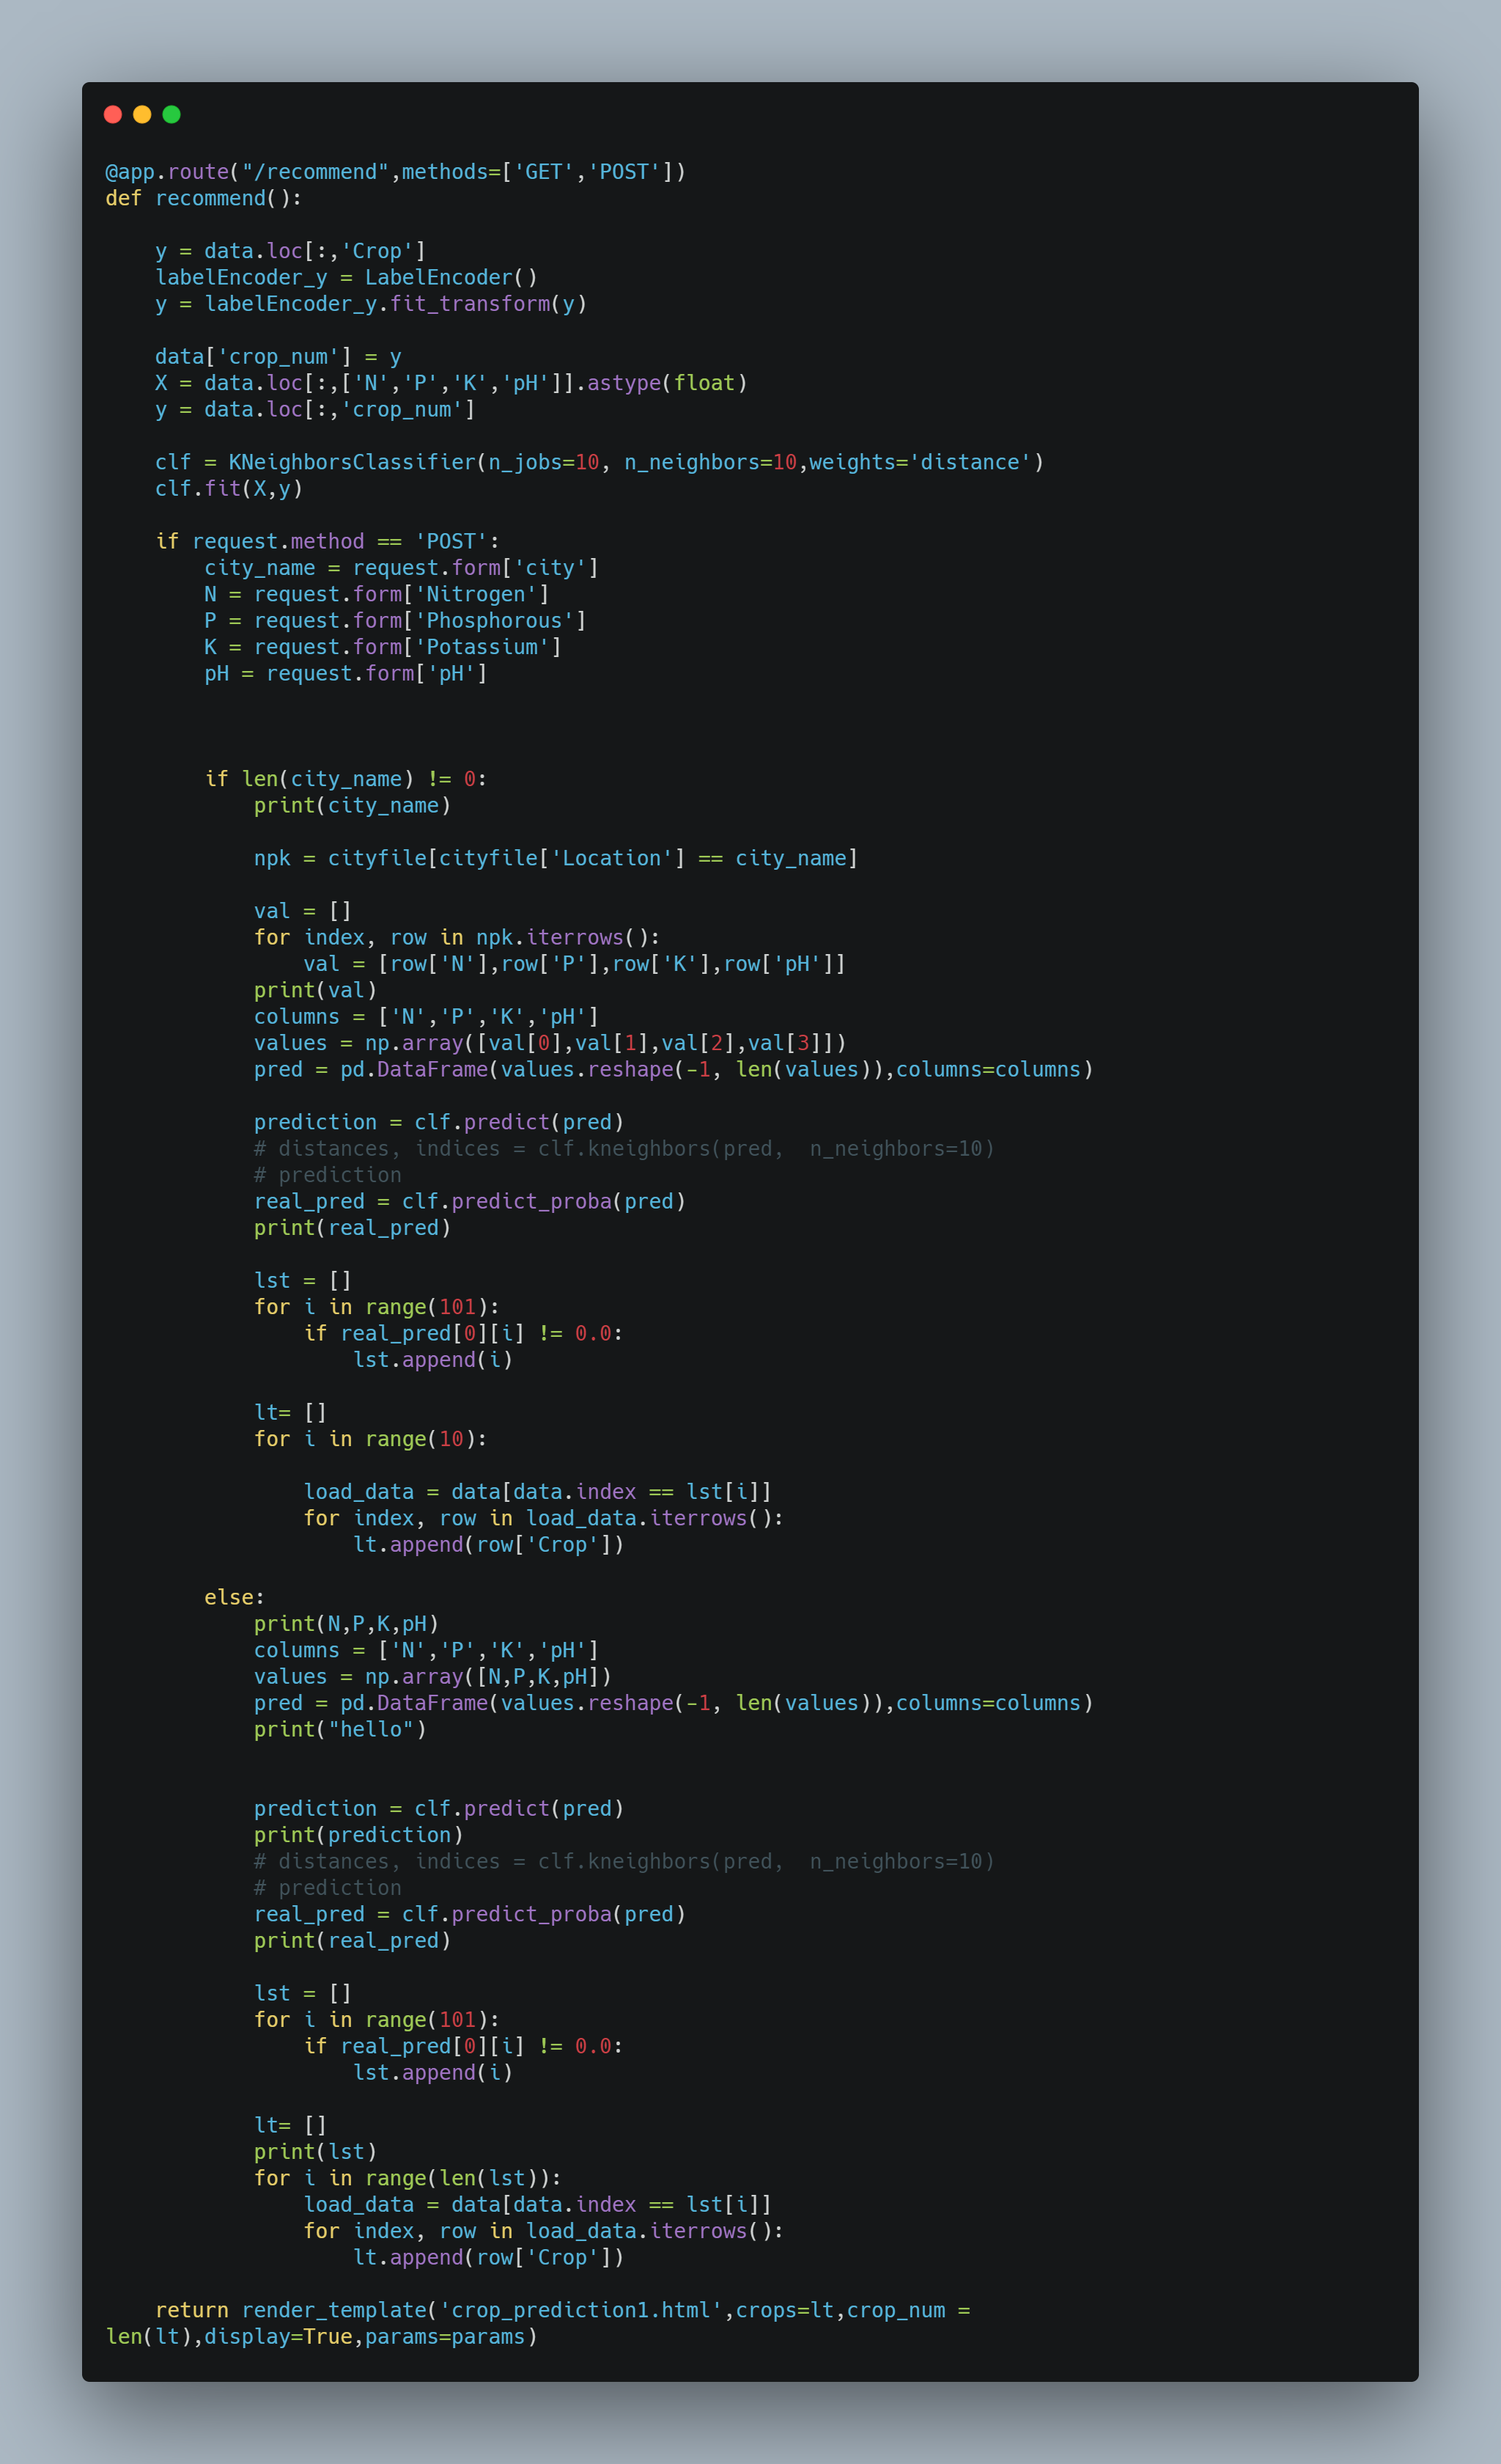

Recommend function is used for crop prediction based on user input. K nearest neighbor model is used here.

There are 2 ways for doing crop recommendation, either user can enter city name or values of attributes (N,P,K,PH). Then those values get stored in the request object of flask, which can be passed as input for recommendation.

Label Encoder has been used to assign integer values to string literals. We have used model.pred_prob() functionality to ascertain probability of prediction, so the crop that has highest value of probability is the most recommended crop.

Eventually the output will be displayed on a web page.

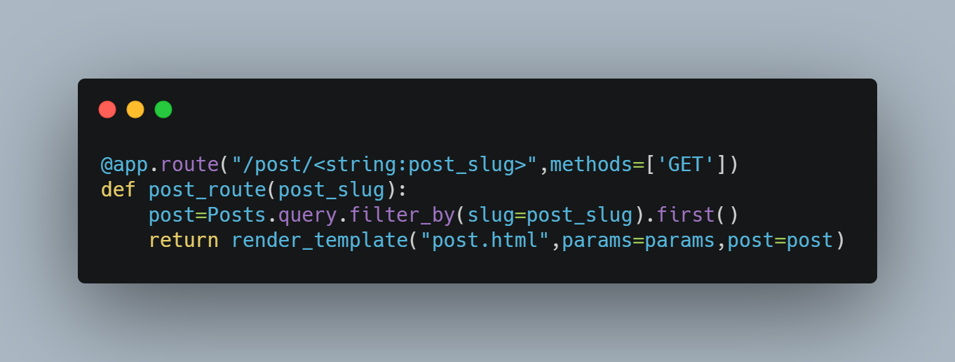

Function used to redirect user to the respective blog post bases on the post_slug

Function to redirect to CONTACT and VACANT LAND webpage. Details get stored in the “Contacts” and “plots” table by using add and commit method.

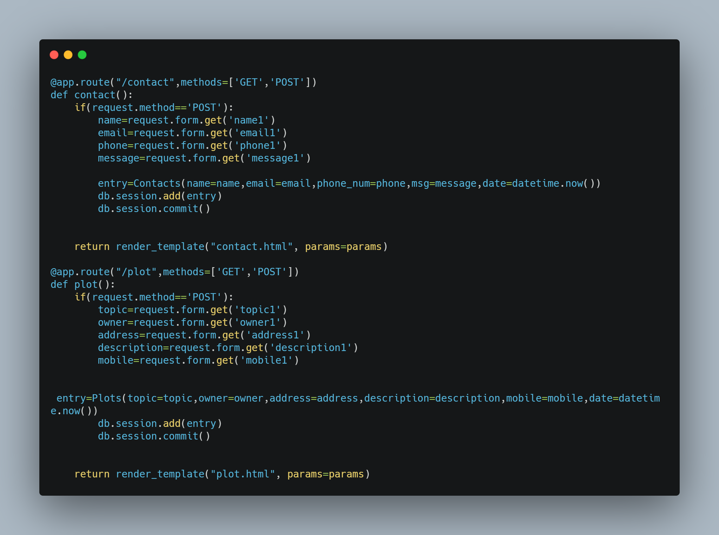

Inside the form tag we take the input from the user for city or different attributes like Nitrogen, Phosphorus, pH, Potassium using the input html tag. Once the form is submitted , recommend function of flask code will be called.

The http method used is “POST”. Label tag to declare the attribute name. “form-control” class is used to make form look more presentable. Autocomplete feature is turned on for each crop attribute.

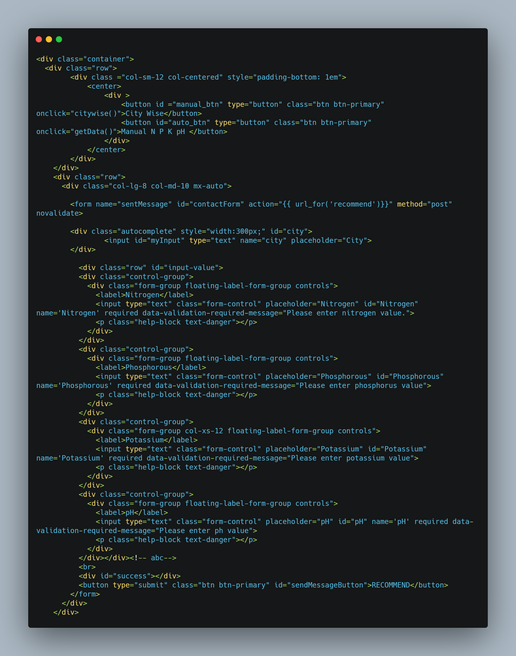

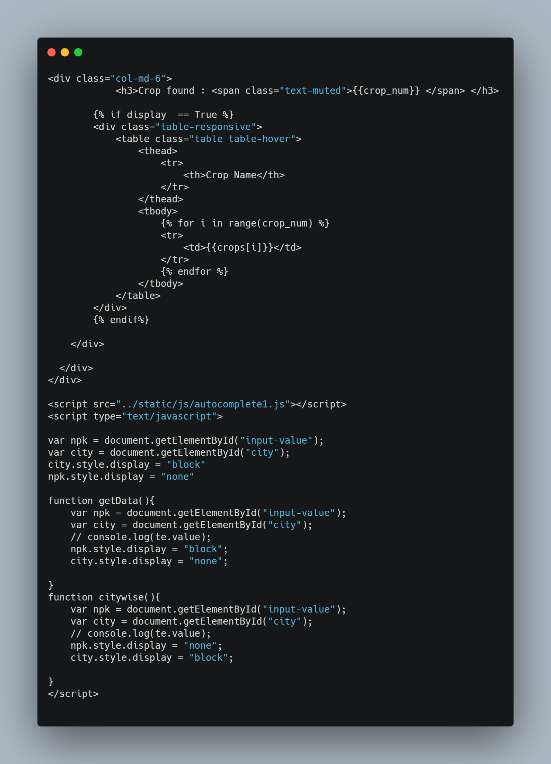

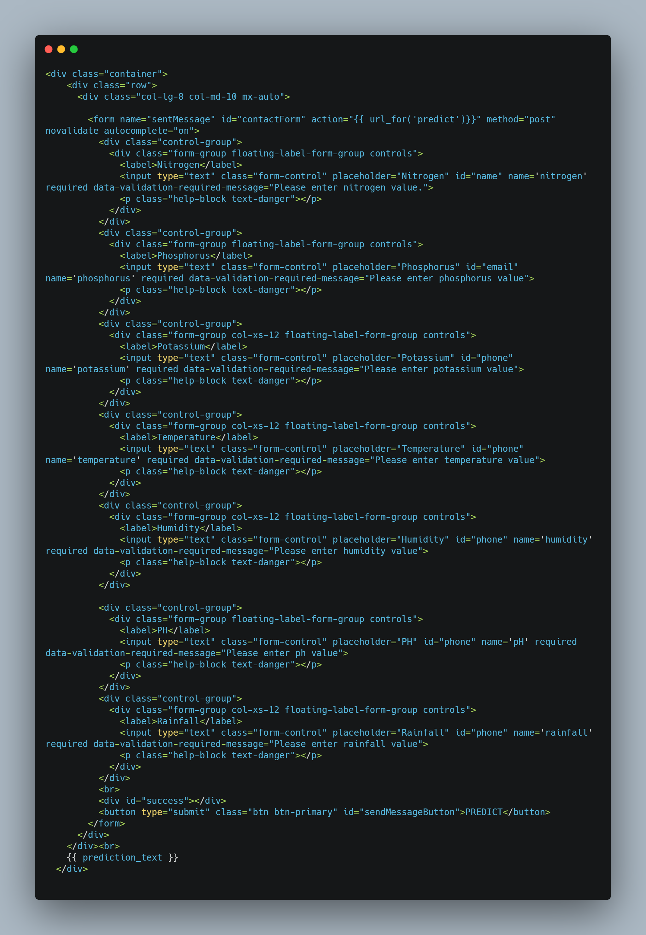

The user needs to input the attributes like nitrogen, phosphours, potassium etc which gets stored in the request flask object. Once all the entries have been done, predict function of flask will be called and using the machine learning model, the crop will be predicted. The http method used is “POST”. Label tag to declare the attribute name.

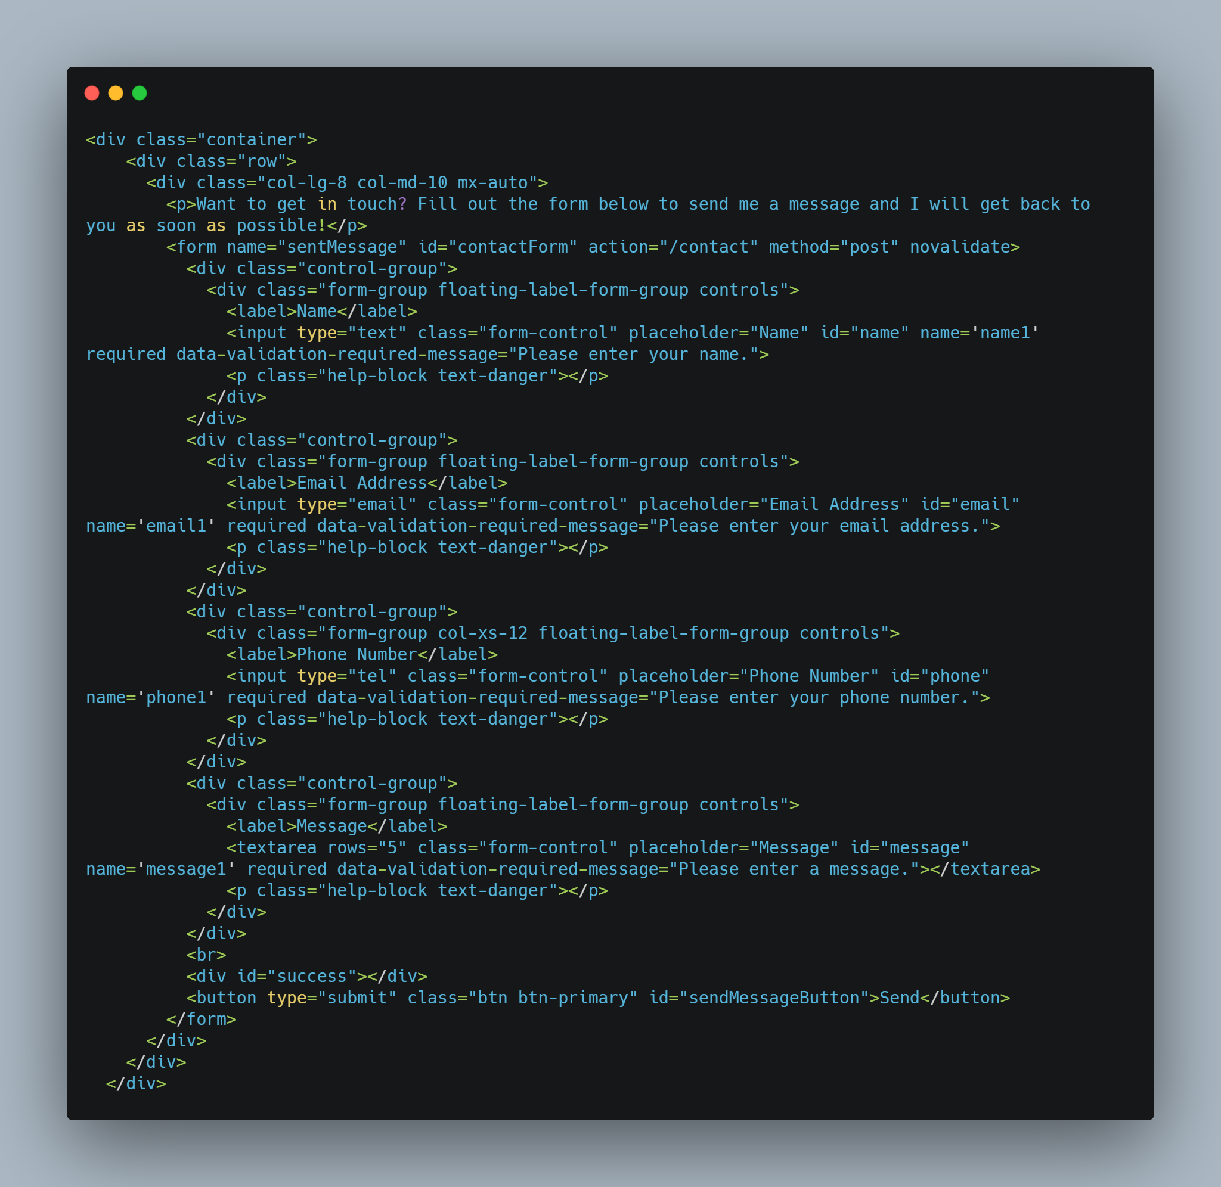

Inside the form tag, we have used the POST http method for security purpose. After submitting the form, it will redirect to contact function (stored in action attribute) in the flask code.

Input tag has been used to take data input from the user. For proper formatting of the html elements, classes like “control-group”, “form-group” have been used inside the div tag.

Login Page

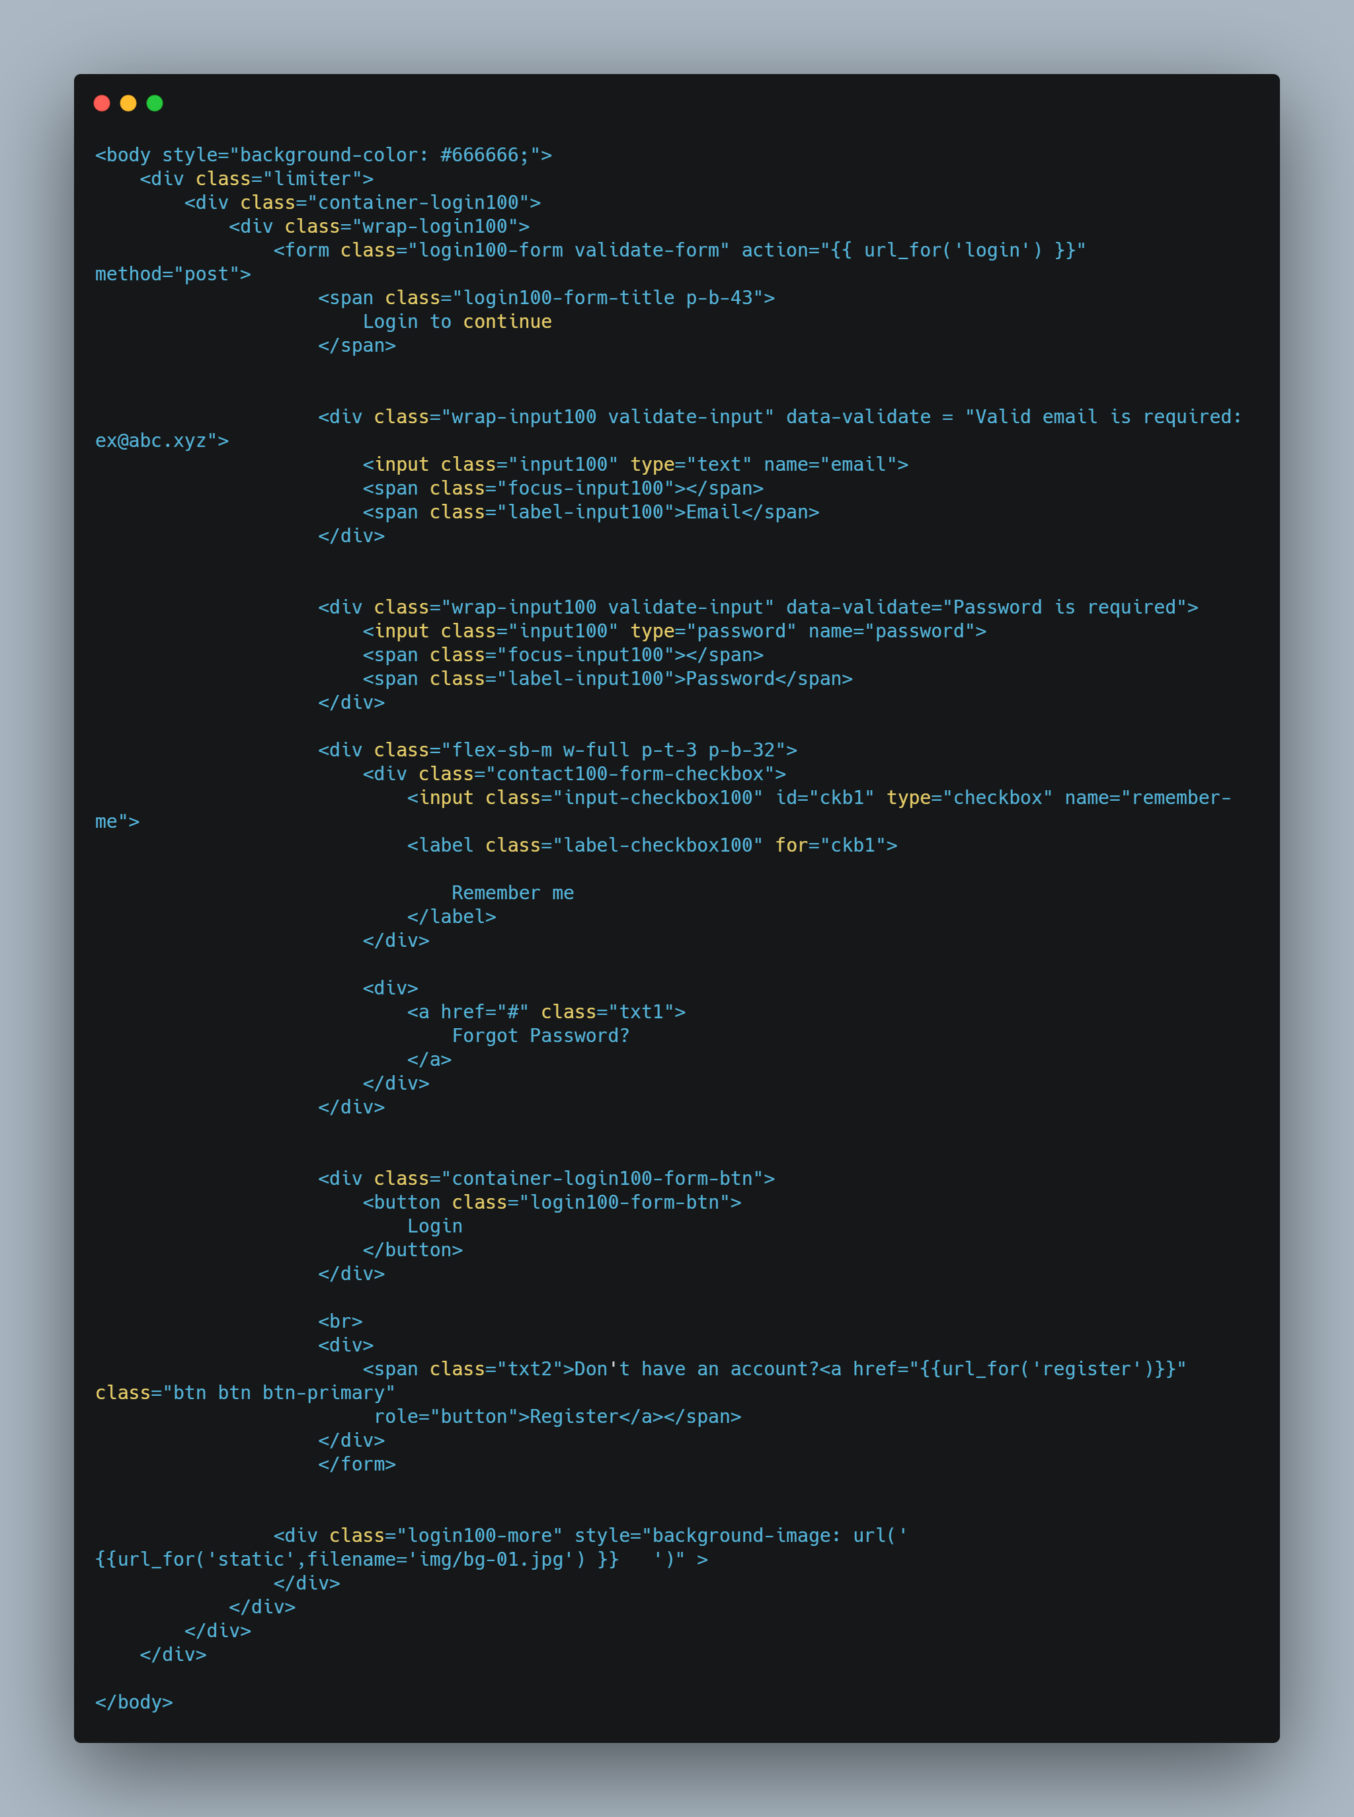

Admin dashboard

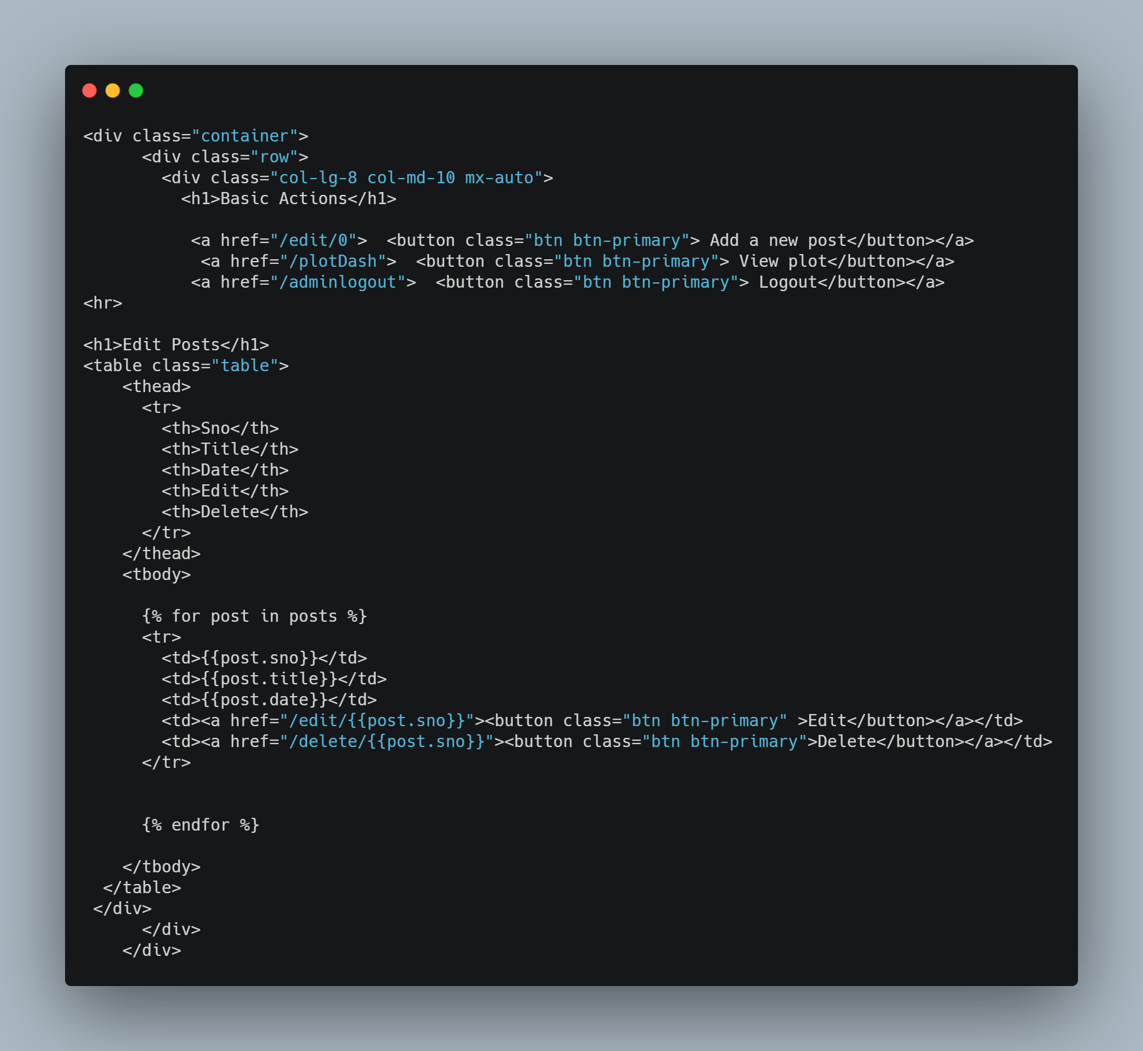

Add/Edit post

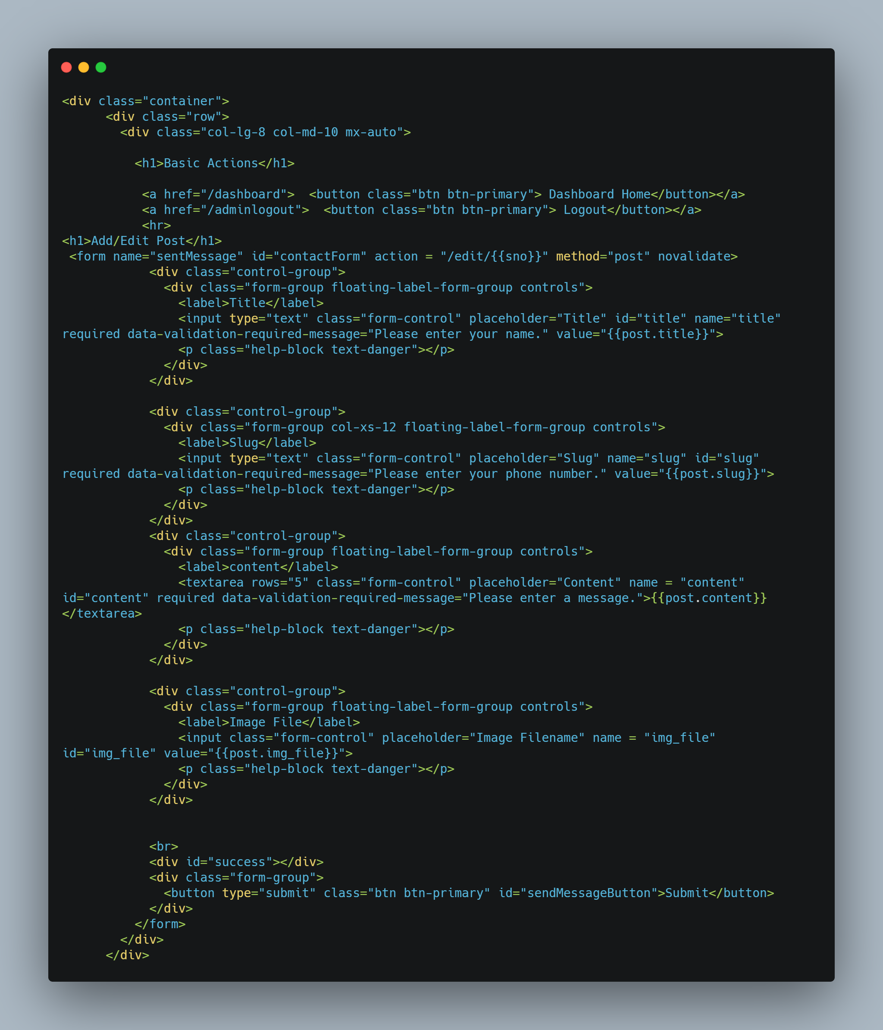

**REFERENCES**

1. D Ramesh, B Vishnu Vardhan. “Data Mining Techniques and Applications to Agricultural Yield Data”. International Journal of Advanced Research in Computer and Communication Engineering Vol. 2, Issue 9, September 2013, pp. 3477-3480.
2. Bharath Kumar R, Balakrishna K, Bency Celso A, Siddesha M and Sushmitha R(2019), ‘Crop Recommendation System for Precision Agriculture, International Journal of Computer Sciences and Engineering(IJCSE), Vol.-7, Issue-5, May 2019
3. Madhusree Kuanr, Bikram Kesari Rath, Sachi Nandan Mohanty(2018), ‘ Crop Recommender System for the Farmers using Mamdani Fuzzy Inference Model’, International Journal of Engineering & Technology, 7, (4.15), (2018), 277-280
4. R.Pallavi Reddy, B. Vinitha, K. Rishita, K.Pranavi(2020), ‘ Crop Monitoring and Recommendation System using Machine Learning and IOT’, ‘ International Journal of Innovative Technology and Exploring Engineering (IJITEE)’, 2278-3075, Volume-9 Issue-9, July 2020.
5. Bhanumathi, M.Vineeth and N.Rohit , “Crop Yield Prediction and Efficient use of Fertilizers” , IEEE International Conference on Communication and Signal Processing, April 4-6, **(2019)**, pp. 0769-0771.
6. M. Ayaz, M. Ammad-Uddin, Z. Sharif, A. Mansour and E. -H. M. Aggoune, "Internet-of-Things (IoT)-Based Smart Agriculture: Toward Making the Fields Talk," in IEEE Access, vol. 7, pp. 129551-129583, 2019, doi: 10.1109/ACCESS.2019.2932609.
7. J. J. I. Haban, J. C. V. Puno, A. A. Bandala, R. Kerwin Billones, E. P. Dadios and E. Sybingco, "Soil Fertilizer Recommendation System using Fuzzy Logic," 2020 IEEE REGION 10 CONFERENCE (TENCON), 2020, pp. 1171-1175, doi: 10.1109/TENCON50793.2020.9293780.
8. A.Chandavale, A.Dixit, A.Khedkar and R.B.Kolekar, "Automated Systems for Smart Agriculture," 2019 IEEE Pune Section International Conference (PuneCon), 2019, pp. 1-6, doi: 10.1109/PuneCon46936.2019.9105686.
9. Suchithra M.S and Maya L. Pai, “Improving the prediction accuracy of soil nutrient classification by optimizing extreme learning machine parameters”, China Agricultural University. Production and hosting by Elsevier **(2019)**, pp. 1-6.
10. Sadia Afrin, Abu Talha Khan, MahrinMahia, Rahbar Ahsan, Mahbubur Rahman Mishal, Wasit Ahmed and Rashedur M. Rahman, “Analysis of Soil Properties and Climatic Data to Predict Crop Yields and Cluster Different Agricultural Regions of Bangladesh”, Journal of IEEE **(2018)**, pp. 80-82.
11. J. Li and L. Zhou, "Research on Recommendation System of Agricultural Products E-Commerce Platform Based on Hadoop," 2018 IEEE 9th International Conference on Software Engineering and Service Science (ICSESS), 2018, pp. 1070-1073, doi: 10.1109/ICSESS.2018.8663921.
12. P. A, S. Chakraborty, A. Kumar and O. R. Pooniwala, "Intelligent Crop Recommendation System using Machine Learning," 2021 5th International Conference on Computing Methodologies and Communication (ICCMC), 2021, pp. 843-848, doi: 10.1109/ICCMC51019.2021.9418375.
13. S. Namani and B. Gonen, "Smart Agriculture Based on IoT and Cloud Computing," 2020 3rd International Conference on Information and Computer Technologies (ICICT), 2020, pp. 553-556, doi: 0.1109/ICICT50521.2020.00094.
14. P Archana Chougule, Vijay Kumar Jha and Debajyoti Mukhopadhyay, "Crop Suitability and Fertilizers Recommendation Using Data Mining Techniques”, Journal of Springer Nature Singapore Pte Ltd. (**2019),** pp. 1-2.
15. S. Y. Liu, "Artificial Intelligence (AI) in Agriculture," in IT Professional, vol. 22, no. 3, pp. 14-15, 1 May-June 2020, doi: 10.1109/MITP.2020.2986121